DEVELOPMENT PROJECT EASY2BOOK

GitHub URL:

<https://github.com/fatimahbadin/DevelopmentProject.git>

Table of Contents

1.0 Acknowledgment 2

2.0 Introduction 2

2.1 Background 2

2.2 Problem and Objectives 2

3.0 Development Methodology 3

4.0 Major Components 5

4.1 Navigation Drawer 5

4.1.1 Overview 5

4.1.2 Design 5

4.1.3 Implementation 6

4.2 Home, Activity, Transport and Profile Fragments 8

4.2.1 Overview 8

4.2.2 Design 8

4.2.3 Implementation 9

4.3 Cinema/Museum, Bus/Train Pages 12

4.3.1 Overview 12

4.3.2 Design 12

4.3.3 Implementation 14

4.4 Confirmation Page 18

4.4.1 Overview 18

4.4.2 Design 18

4.4.3 Implementation 18

4.5 Login and Signup Page 21

4.5.1 Overview 21

4.5.2 Design 21

4.5.3 Implementation 22

5.0 Testing 26

6.0 Further Development 26

7.0 Critical Analysis and Reflection 26

8.0 Conclusion 27

9.0 References 29

10.0 Appendices 30

Appendix 1 – Testing 30

Appendix 2 – UML Diagram 33

Appendix 3 – ERD Diagram 34

# Acknowledgment

During these three years in university, I have received some of the best support and advice from those closest to me as well as others that I have just met once. I would like to take this opportunity to, first, thank my family for their continuous support throughout my life and always providing great advice. Although they may not know much in relation to my course, they have always stood by me and motivated me to do my best. I would also like to thank my friends; the friends I have made during university and the friends I have known for a lot longer. All of these friends played a huge part in my life, during these three years. Especially when the stress of the deadlines would get to me, my friends would be there to relieve some of that stress. My friends, like my family, would also push me and motivate me to achieve the best I can and complete the tasks that I needed to complete. Additionally, I would also like to thank my supervisor Vasileios Germanos for his assistance through this project. He has provided me with help throughout the year which has helped me achieve the grades I have so far. I am grateful for Usama Mannai and Dr Ali Jwaid for also providing me with sources and information in relation to Android Studio and mobile applications.

# Introduction

## 2.1 Background

Easy2Book was designed to make it easier for users to book for activities and transport within one application. Over the years, technology has evolved rapidly and many people now plan and book trips online before using the service or facility. Planning and booking full days out can be quite a lengthy process and can become stressful whilst browsing through multiple different websites and applications. The main reason for the creation of Easy2Book was because of how time consuming and frustrating it can be to plan and book a short trip, browsing through multiple websites and applications and still struggling to find anything useful. One of the main purposes for Easy2Book is to make it less time consuming and less frustrating for users to book their activities and transport. Easy2Book includes a couple of activities and some transport options that will take the user directly to their activity, if needed. The application has been designed for android devices thus targeting users with android devices, including users who would like to book their activities and transport for their trip.

The software that was used to develop Easy2Book is Android Studio. During the development of Easy2Book, Android Studio was also used to help test the application to ensure all of the components were working as planned and to ensure the application did not crash at any point, while using the application. The coding language Kotlin was used for the creation of this application and as for the database, SQL and SQLite were used. Both the software and the language was quite new to me, however, a lot of research and exploring of the software had taken place in order to complete the application.

## 2.2 Problem and Objectives

As mentioned above, the motivation behind the development of Easy2Book was mainly due to the fact that it can be very time consuming and frustrating browsing through multiple different websites and applications in order to plan and book a short trip. Many people now usually book online beforehand rather than just turning up. When researching, before developing the Easy2Book application, there were not many applications that allowed for users to book their transport alongside their activity within the same application. The overall aim of the project was to create a mobile application that would allow users to easily book a trip within one application.

At the start of the project, a contract was formed which included the objectives of the application. One of the objectives for the application was to display a couple different options for entertainment and transport for the user to select from. Having a couple of options for each of the sections gives the users a choice rather than forcing them to only have one choice. Additionally, one of the main objectives is to allow the users to book for their choice. After the user has made their choice, they should be able to go through, make a few changes and book for their selected option. Another objective was to ensure the interface of the application is suitable for most users. This is in regards to the colours of the application, the font size and the placements of each of the items on the pages. The colours should be simple and be consistent throughout the application. The application should be clear and pleasant to look at, while in use. This means there should not be a huge variety of colours and this does not always appeal to the majority of users. Relating to the font of the application, when users use the application, they should not struggle to understand what they need to do or what the page reads. The font should be set to an appropriate colour against an appropriate coloured background and the font should not be too small so that it can be read by majority of the users. In the next few sections, explanations of how each of the objectives have been met will be provided.

# 3.0 Development Methodology

The development methodology that I had decided to use during this project is the Agile with SDLC (Software Development Life Cycle) methodology. With the Agile and SDLC methodology, the major components of the project are split into sections and completed through an iterative cycle. In the same way, my project was split into different sections and I had worked through the cycle for that section before moving onto the next section. By using this methodology, it allowed for me to focus on one part of the application, ensuring everything is working as it should be, before moving onto the next part. It also helped with the management of the whole project and plan when I should have each part of the project completed by and ensure to test it before moving on. Additionally, with this type of methodology, I had multiple meetings with my supervisor which including discussions on what stage of the project I am on and what I was planning to do next. This also helped me with management of my project and the development of it.

In relation to management, I had created a Gantt chart at the start of the project which was a visual representation of how I would be completing the project. While developing and completing the project, I was able to refer back to the Gantt chart and make changes, where needed. The initial Gantt chart did not necessarily align with the methodology I was working with so a few changes had been made to the chart. If a certain section took me a little longer to complete than planned, I would edit the chart to show that and also edit the sections that would come after to ensure I am giving a realistic timeline for the sections to be completed.

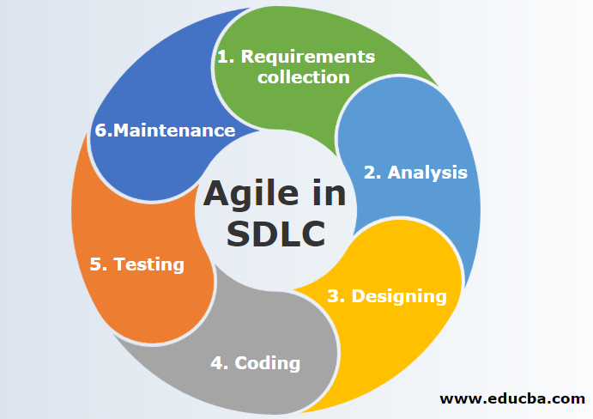Figure 1: Agile in SDLC methodology diagram [1]

# 4.0 Major Components

## 4.1 Navigation Drawer

### 4.1.1 Overview

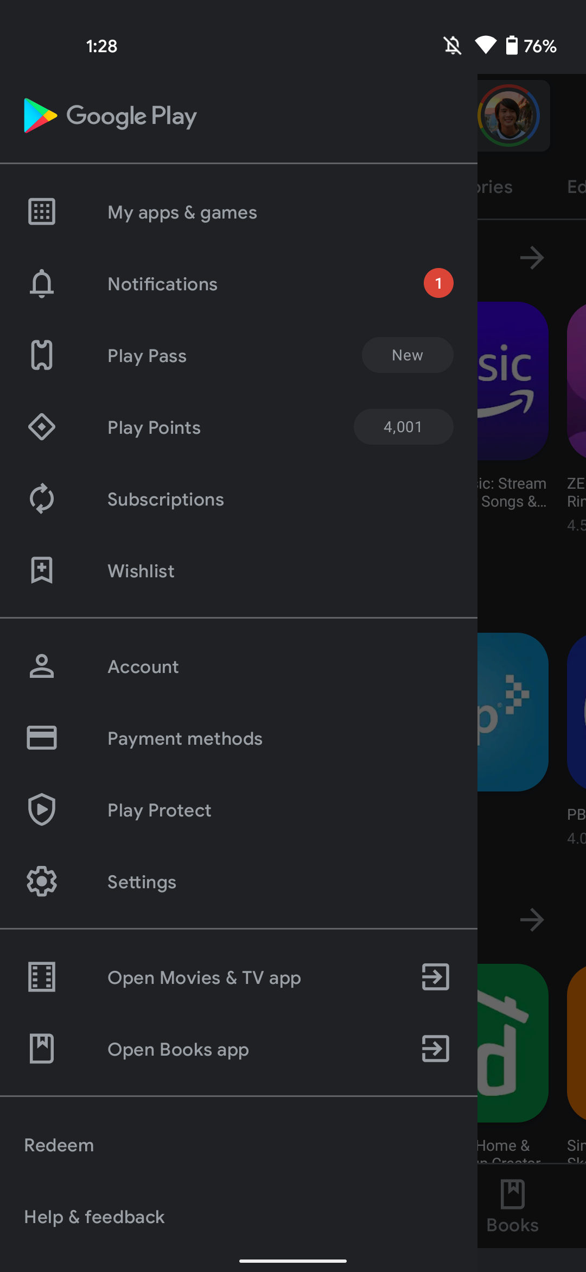One of the first components that is found within the application, after logging in, is the navigation drawer. The main purpose for the navigation drawer is to allow for users to be able to navigate to other pages easily rather than going back to the home page and clicking multiple buttons before reaching their desired page. Due to the application having a few different pages, I felt that a navigation drawer would be quite useful for users to navigate through the application. Additionally, majority of the applications, if not all applications have a navigation drawer to make it easier for the users to navigate through the applications. The inspiration for the navigation drawer came from many different applications, some that I use on a daily and some that I do not use much at all. One of the main applications that I had got inspiration from would be the Google Play Store, like in figure 2. I had also used a couple YouTube videos and a website that I used for inspiration [6, 7, 8].

Figure 2: An image of the Google Play Store navigation drawer [2]

### 4.1.2 Design

The design that I had decided to go with for the navigation drawer was a quite simple design. The top of the navigation drawer simply holds the name of the application, “Easy2Book”. Initially, the idea was to have the user’s username and email displayed, however, this did not work as planned and the details were not displaying so I decided to display the name of the application instead. As mentioned above, I took inspiration form the Google Play Store navigation drawer. The “Home”, “Activity” and “Transport” navigation tabs are placed in one section and the “Profile” navigation tab is places under the section called “Profile”, like how the Google Play Store navigation has its tabs in sections. The reason for this was to make it clear that there are two separate sections and the “Profile” is separate from the other pages. The icons used before the name of the tab represents what each page is about, they were added so that the navigation drawer does not just include text and makes it look a little less plain and also shows the user what is included in those pages. Thus, having the divide and the icons makes the navigation drawer have a more aesthetic look to it and clearer to the user. Setting the navigation drawer this way aligns with one of the objectives in my contract which was to ensure all 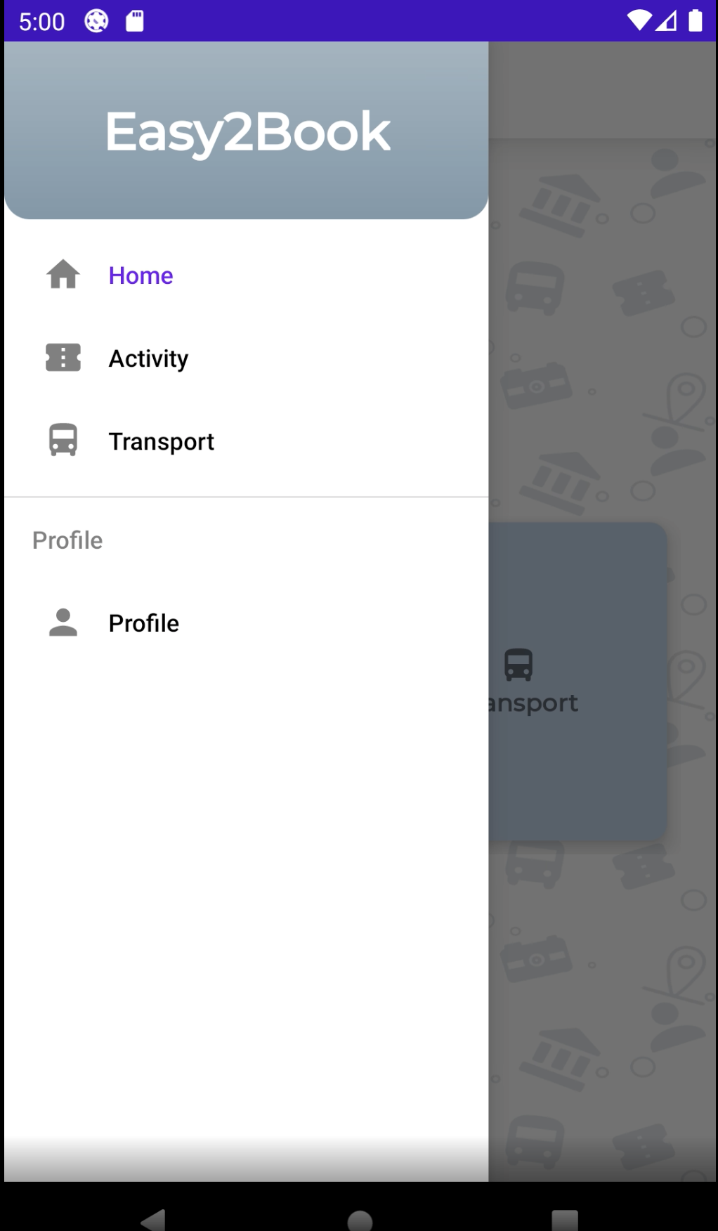content is clear to the users.

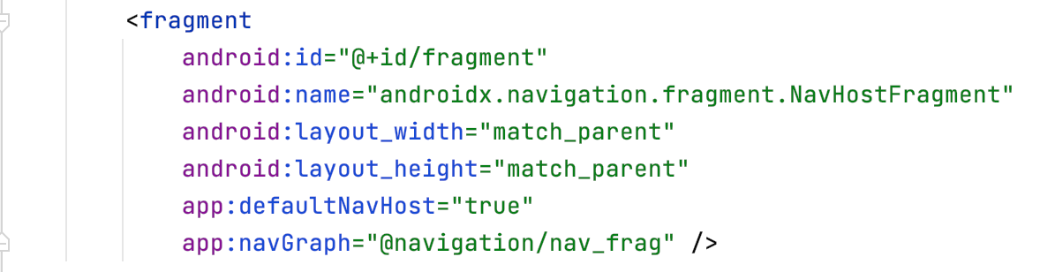Figure 3: An image of the navigation drawer within the Easy2Book application

Figure 4: The xml code for the fragment container within the main home page xml file

The Above code is from the main home page xml file and it is the code for the fragment container. The container is empty and is there for the other fragments’ content can be displayed when the user clicks on the tabs within the navigation drawer.

### 4.1.3 Implementation

With the navigation drawer, there was one main page which would display the content, the tabs within the navigation drawer are fragments of the main page. When each of the tabs are selected, the main page would display the content for the fragment that had been selected. The main page for the navigation drawer is the Home page and the xml for that page included the top custom action bar and a fragment container. Initially, the fragment container is empty, however, the home tab within the navigation drawer has been set to load into the fragment container first and when each of the other tabs are clicked, the fragment container will replace the home fragment with one of the other fragments. Figure 5 shows the code on the main Home page including comments on what each part of the code does. For the navigation drawer to function, dependencies were added to the build.gradle file, figure 6 shows the dependencies added.

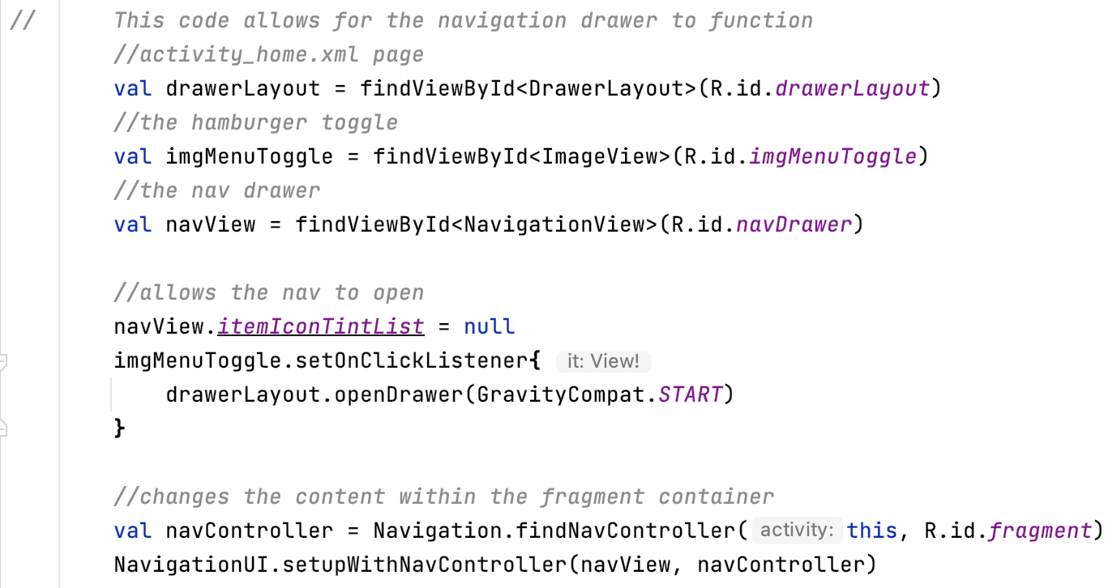Figure 5: An image of the code from the main Home page including comments for each part of the code

Figure 6: The dependencies in build.gradle

Above, in figure 5, the first value retrieves the drawer layout in the main home page xml file. The drawer layout is essentially the whole of the page including its contents, “drawerLayout” is the ID for the drawer layout. The second value retrieves the hamburger toggle which is a vector asset that was found within the android studio assets. The third value retries the navigation view of the drawer, which is essentially the navigation drawer that will be displayed in the application. “navDrawer” is the name of the ID that is found in the “navDrawer” xml file which includes the navigation header and the items that will be displayed in the navigation drawer.

The code below the values, gets the navigation view and sets the time for the icons to null. This is so when the tab is clicked, only the text changed colour and the icon will stay the same colour no matter which tab has been clicked. The code just under that is what allows for the navigation drawer to open using the hamburger toggle. The code under the toggle is what changed the content when the tab is clicked. The first line is a value that retrieves the fragment container in the main home page xml file. Within the brackets, the “navView” will refer back to the navDrawer and the tab that the user had clicked on, the “navController” refers back to the fragment container. This part of the code will replace the fragment container with the “navView” and specifically the tab the user had clicked on.

## 4.2 Home, Activity, Transport and Profile Fragments

### 4.2.1 Overview

The next part of the application are the fragment pages that are used within the navigation drawer. The home, activity and transport pages are all more or less the same with some slight differences. The profile page will display the users details and allows the user to sign out from this page. The inspiration for the profile page came from a couple YouTube videos I had watched while doing the research for the development of this application [12, 13]. The home allows for the users to be taken to the activity and transport pages, depending on which button they click on. The activity page would take the user to the cinema page or the museum page based on which the user would like to visit. The transport page would take the user to either the bus page or the train page. This aligns with one of the objectives on the contract which states that the user should be given a couple of choices to pick for their activity and for their transport.

### 4.2.2 Design

The design for the homage, activity and transport pages are all the same (see figure 7). There are two card views on each page which displays text for which page they will be visiting and an icon that represents the page they are visiting. The colour of the card views and the text are in line with the colours for the rest of the application to keep it all consistent. At the top of each of these pages is the name of the page that the user is on, again the text colour is in line with the rest of the application and has a white background so that the test can still be read with the background of the page. I had created the background using Procreate, I used the vector assets that I have used within the application and drew them, including a couple other drawings then created a pattern with the drawings for the background. I got inspiration for the background from a picture on Google [3].

Figure 7: Three of the fragments

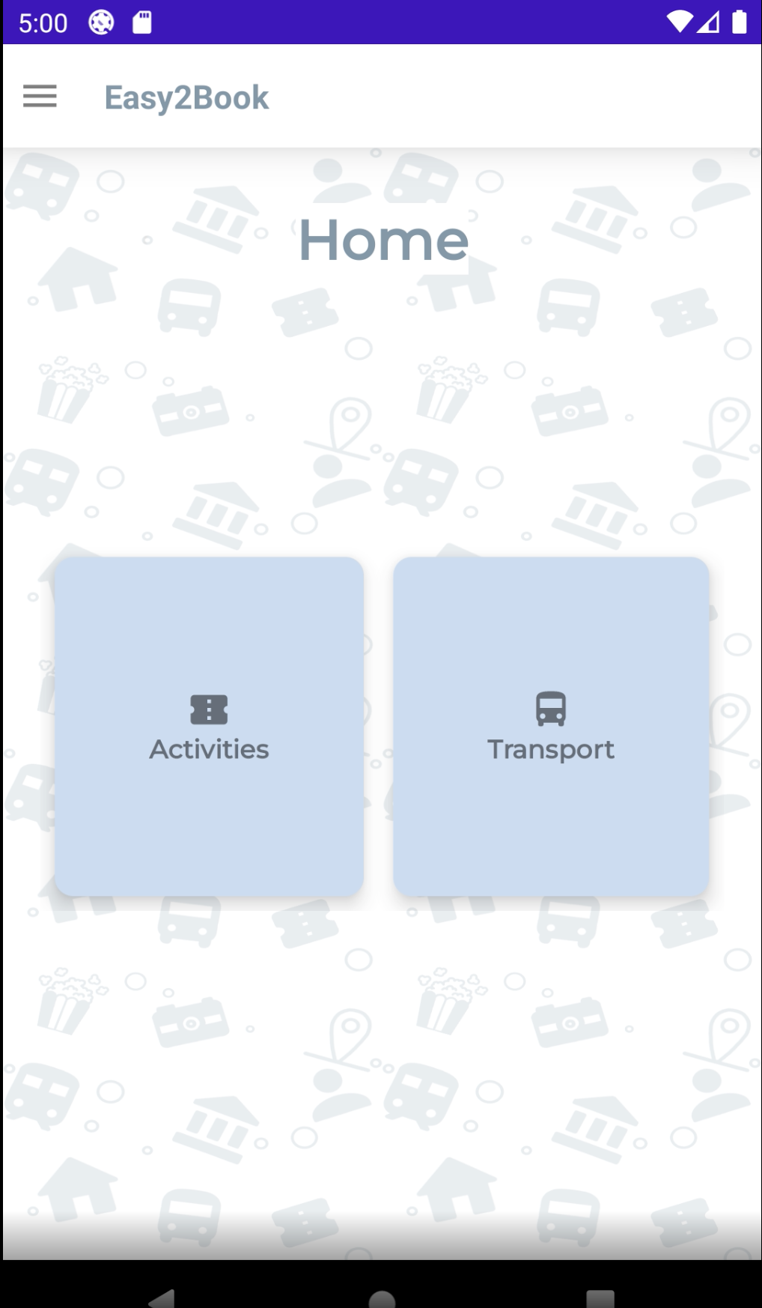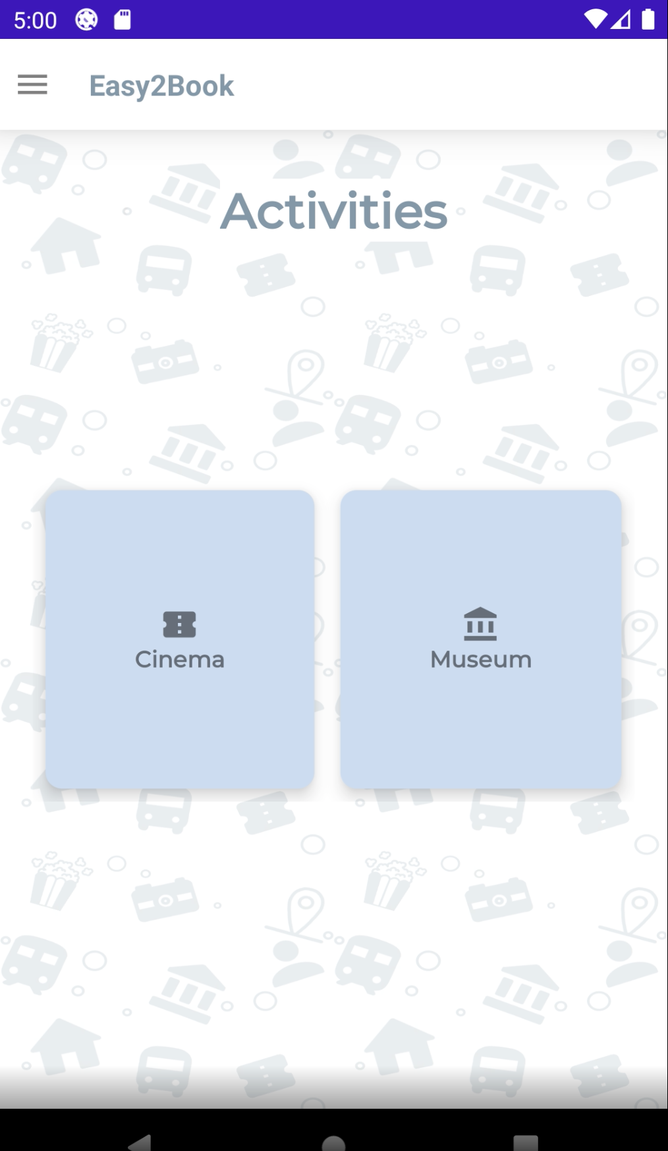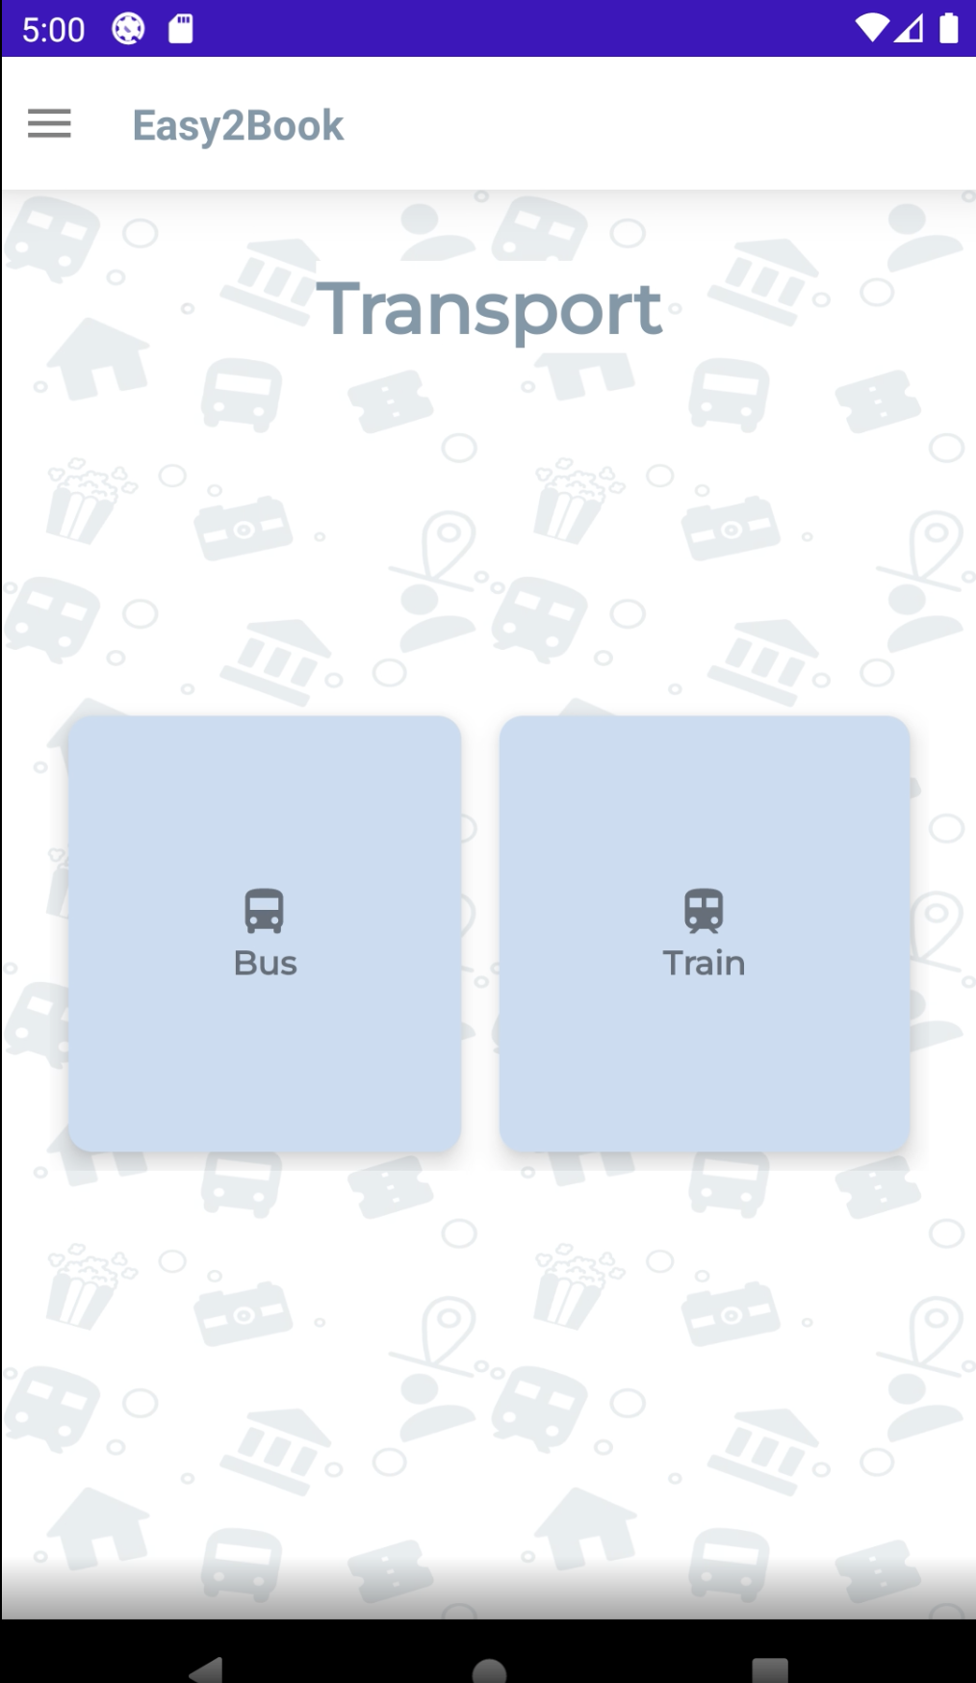

Figure 8, below, shows the profile fragment. For this page, “My Profile” is clearly labelled at the top with the same formatting as the title for the other pages. A scroll view has been used for this page to display the username and the email. Also, including within the scroll view is a section that allows the user to sign out. For the scroll view to function, a couple other xml files had to be created and then included in the profile xml file (see figure 11). The button is styled in the same way as the buttons on the login page so that it is consistent.

Figure 8: The profile fragment

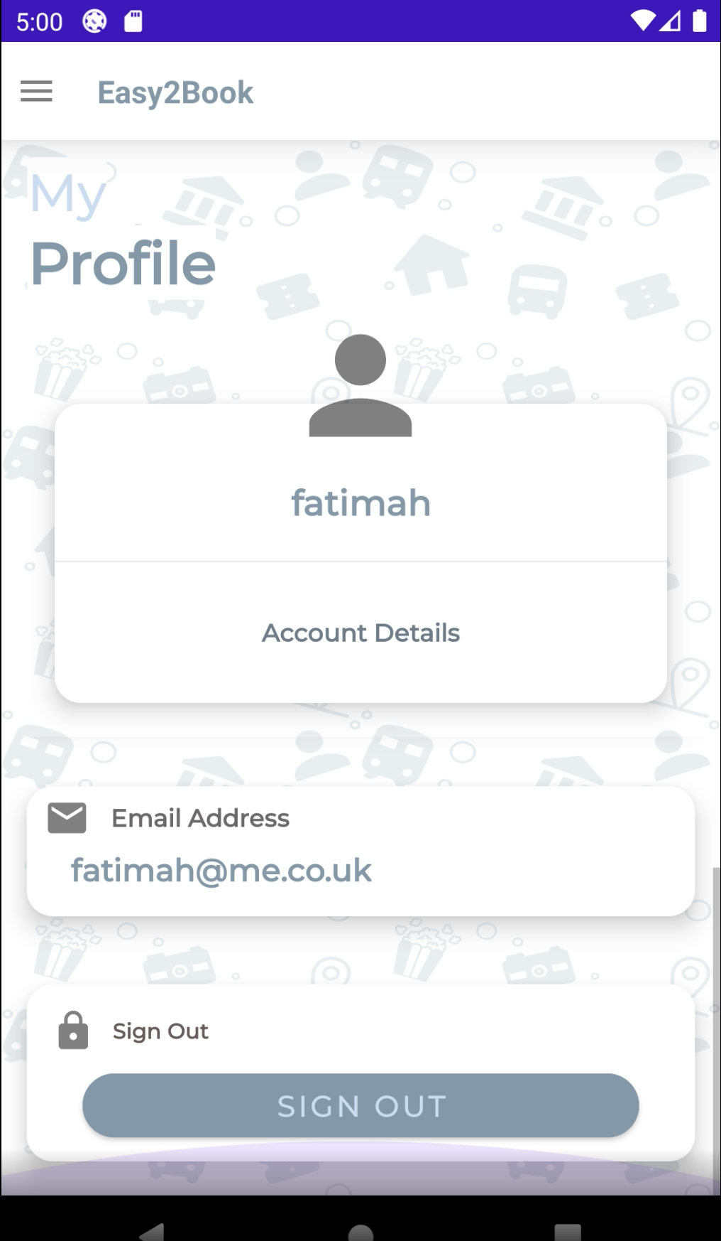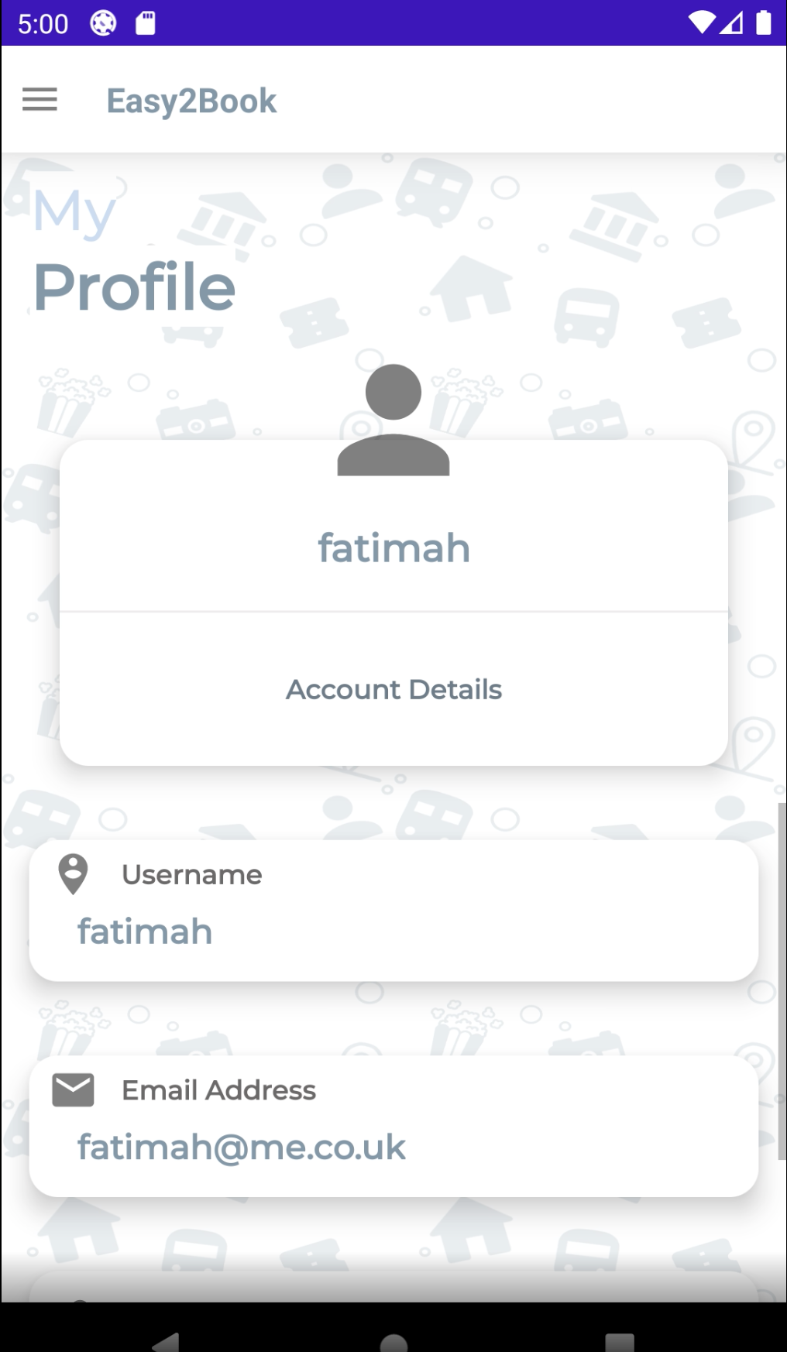

### 4.2.3 Implementation

The implementation for the home, activity and transport pages was not too difficult. However, when I was trying to implement the onclick to allow the user to go from the home page to either the activity or the transport page, it did prove to be a bit of a struggle as an Intent does not work from fragment to fragment. After a good amount of research and conversing with one of my mobile application lecturer, Usama, I was able to find a couple sources online that helped me implement the code to take the user from one fragment to the other [4, 5]. In figure 10, at the top there is some code which calls on the database helper and retrieves some data from the transport table. This is so the text of the card view can be set to the first transport within the transport table, in the database, and the second card view will display the second transport within the table. The values, before the setOnClickListerner function, retrieves the card view that is used as a button and saves it. A setOnClickListerner is then added to the value, this is so the card view can be clickable and when it is clicked the code within the function will run, this is the same for the three pages (home, activity and transport). In this case, the code within the function calls on the parentFragmentManager and beginTransaction is applied. This allows for the fragment container to replace the content of the current fragment with the content of the new fragment. Figure 9 shows the code that was used for the fragment to fragment navigation.

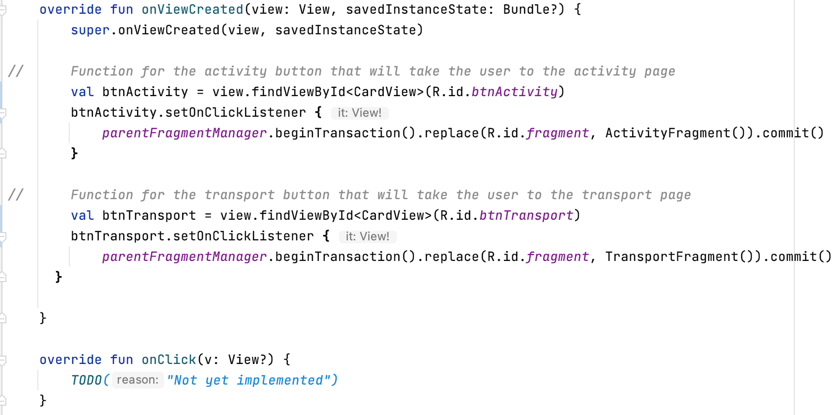Figure 9: The code within the home fragment

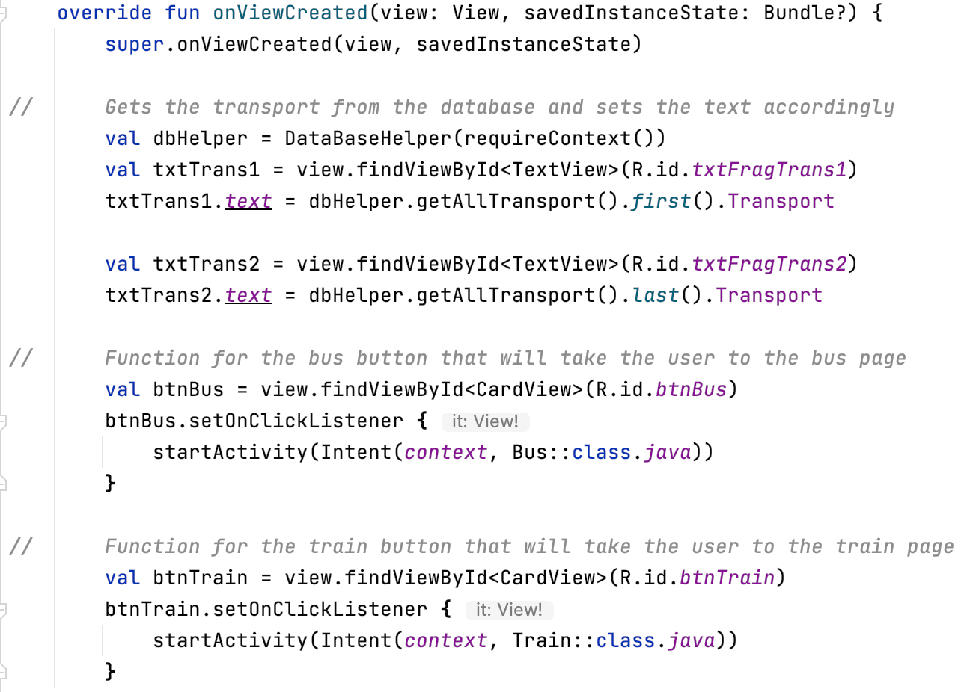Figure 10: The code within the transport fragment

Going from a fragment to an activity, I was able to use the Intent which was not difficult to implement as Intent has been using throughout the application. The Intent simply replaces the current page with the next page that is being visited. Figure 10, above, shows the code for the Intent in the transport fragment. The code in the activity fragment is the same but for the cinema and museum pages instead of bus and train pages.

For the profile page, other xml files were created and included within the profile xml page, as shown in figure 11. As for the implementation for the username and email being displayed, another user table had been created and included within the database helper. When users logged in their details would be saved to the userLogged table. This would mean the user that has just logged in, their details will be the last row within the table in the database. Therefore, when setting the text of the text views, the last row of data is retrieved from the userLogged table. When the last row of data is retrieved, the username and email was also retrieved and displayed in the sections that needed those details (see figure 12). As for the sign out button, a dialog box was included to confirm that the user would like to sign out (see figure 13). An AlertDialog builder was used in order to display and use the dialog box. If the user clicks no the dialog will simply close, if the user confirms they want to sign out, they will be taken back to the login page.

Figure 11: The xml files and the code within the profile xml file

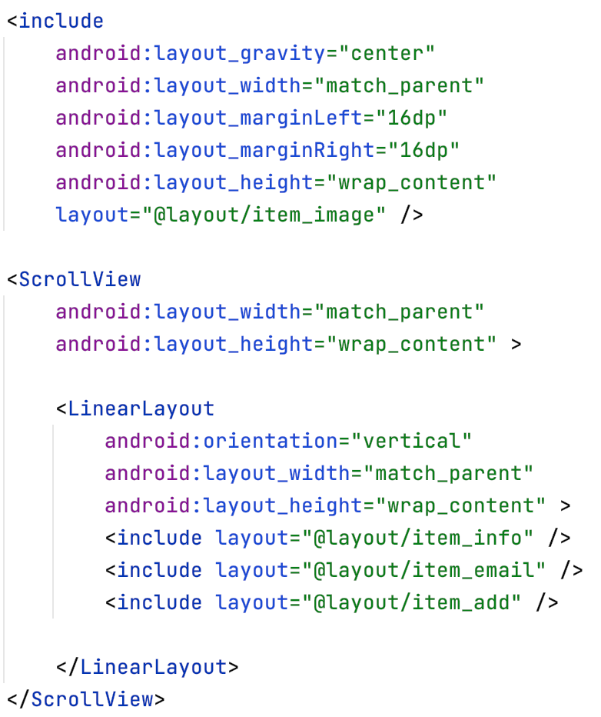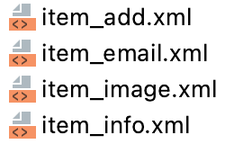

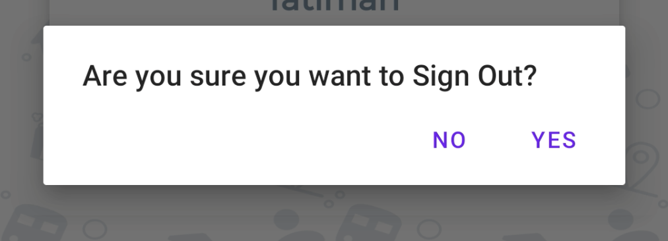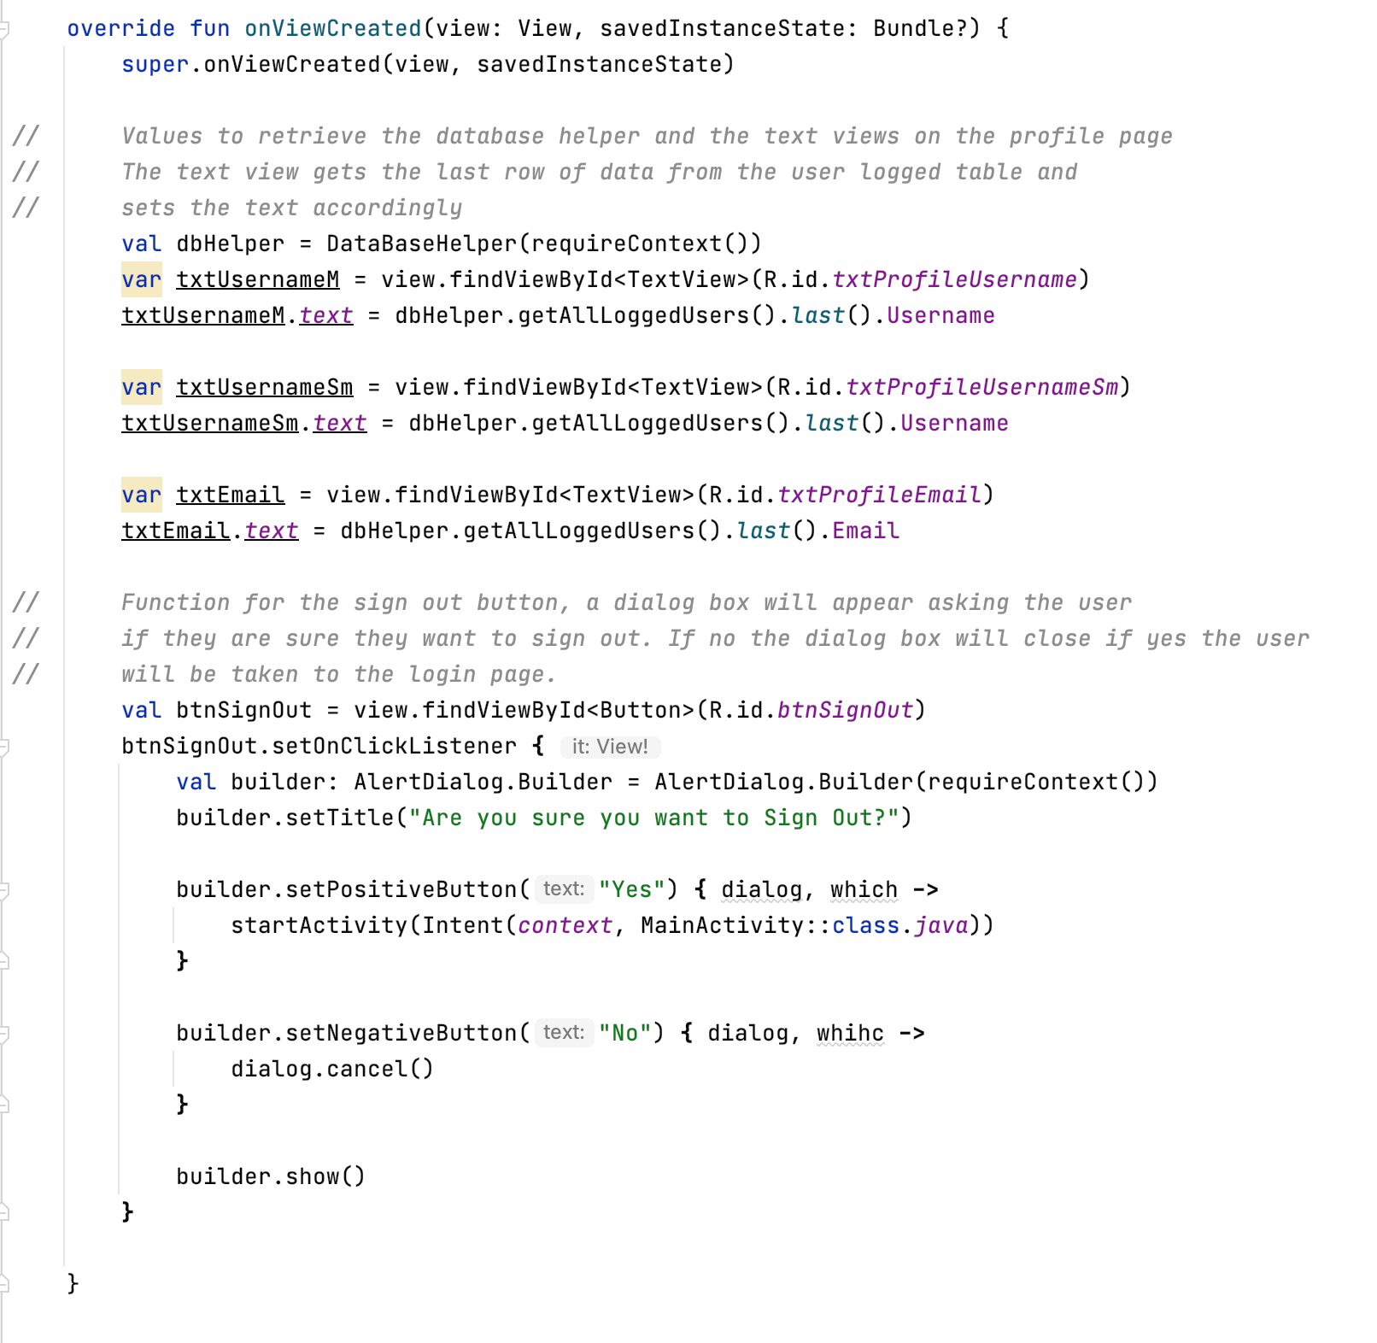Figure 12: The code within the profile fragment

Figure 13: The dialog box

## 4.3 Cinema/Museum, Bus/Train Pages

### 4.3.1 Overview

These pages have more or less the same layout and have the same colour theme, to keep it consistent with the rest of the application. These pages allow users to make choices, for example, on the cinema page, users can select from 2 different movies and 2 different times, they are able to enter the number of people they would like to book for and also the date they would like to book for. The other three pages have a similar concept in the sense they can choose from a couple different options, enter the number of people and the date they would like to book for. This aligns with the objective, in the contract, that states the user should be able to make a choice. Each of the pages allows the users to make a choice, they are not given only one option. Once the user has made their choices they will be able to click the “Confirm” button and this allows them to successfully finish their booking. This aligns with one of the other objectives which stated that user should be able to book for their activity or transport.

### 4.3.2 Design

The design for each of these pages is the same, bar the actual content within the pages. Each page has the name of the page displayed at the top, a card view in the middle with all of the main content, a confirm button at the bottom and another button at the top left of the page (see figure 14). Keeping the same design for the page gives the application a more aesthetic look and it looks more put together rather than all over the place. This meets the objective in the contract that states the text and content should be clear to the user, all of the text on these pages are clear, set of an appropriate font size and an appropriate colour. Also, meeting that contract objective in ensuring users know what to do and everything is clear, the user input, for the date, has the hint “DD/MM/YYYY” which clearly shows how the date should be entered into the text box. This helps with any confusion the user would have as there are many different ways of entering a date. The button, on the top left, holds the home icon as it takes the user back to the home page, when clicked. The confirm button displays a dialog that confirms the total price for the booking before the user proceeds, as shown in figure 15.

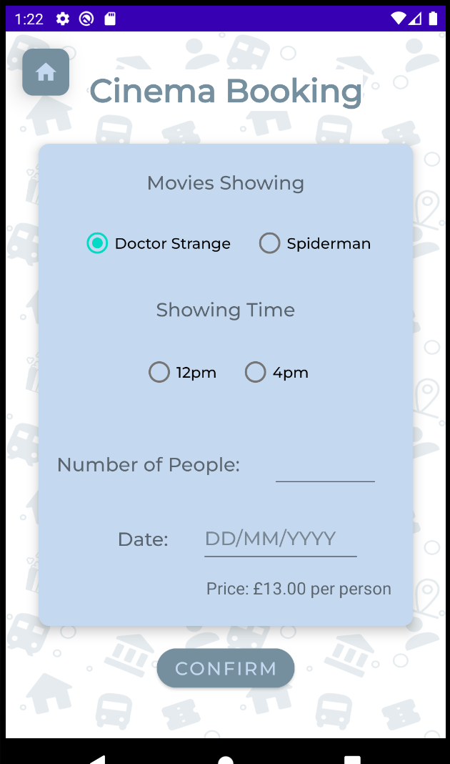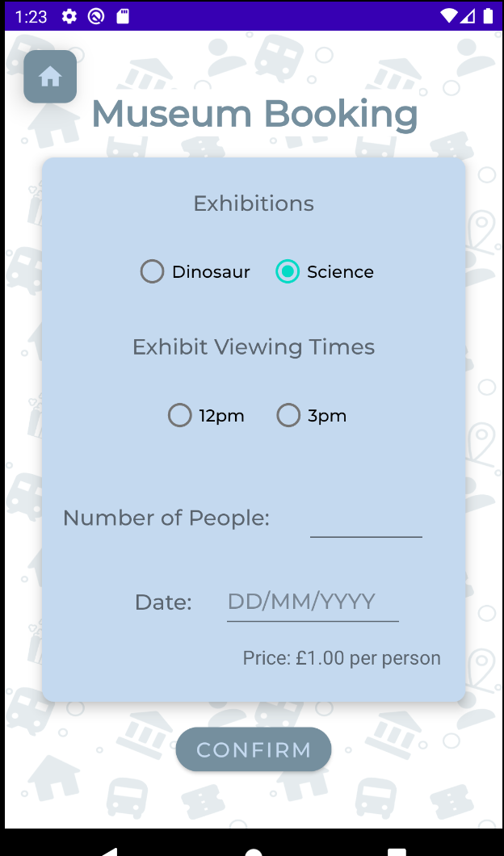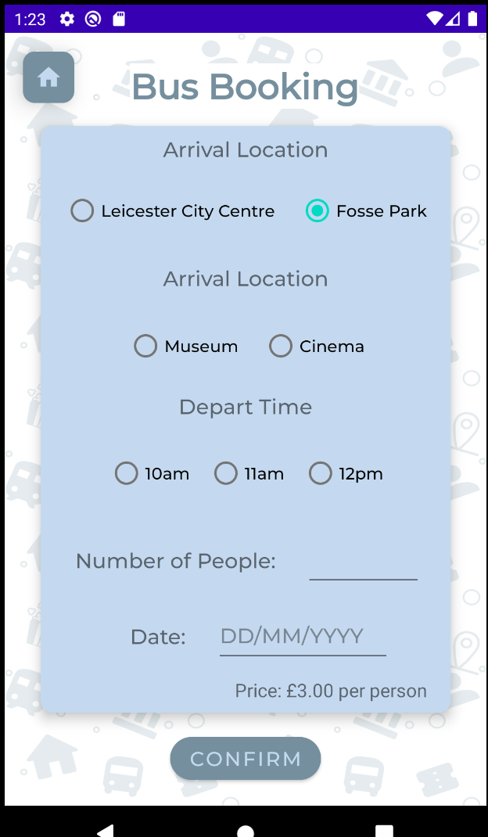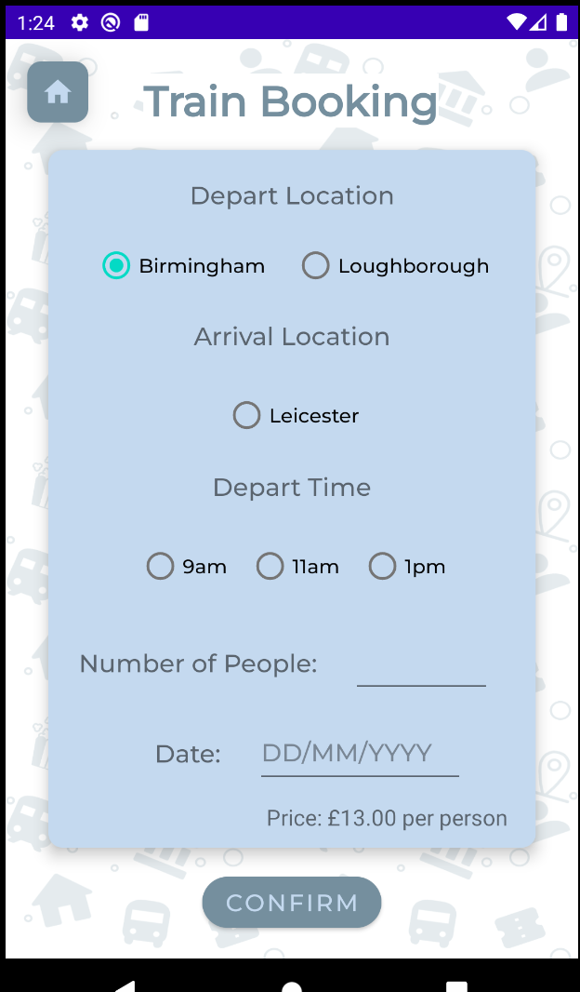

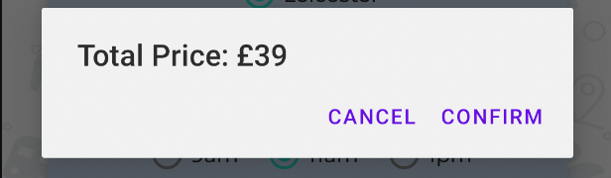Figure 14: The design for the 4 pages

Figure 15: The dialog box for total price

### 4.3.3 Implementation

For all four of these pages, the implementation is more or less the same but the content is of course different for each of the pages. The function, in figure 16, if for the button with the home icon. The function uses the Intent to simply take the user back to the home page. The Intent replaces the current page with the home activity. This is the same for the home buttons on all of the pages. In figure 17, there are lines of code which are placed at the top of the page, these lines of code will run when the page is initially loaded. The code, in figure 17, is from the cinema activity so using this example, the first value retrieves the database helper and saves that into a variable. The next two values use the database helper variable to call on the getAllCinema function (see figure 18) which retrieves all of the data within that cinema table, the get(0) and get(1) retrieves the row 1 and row 2 within the cinema table and the MovieName selets only the data within the movie name column.

The next lines of code are values that have been created to store the text of the radio buttons that the user would select when picking their options. Using the values, the radio button text is then set to the data that has been retrieved from the cinema table in the database. After that, the times for each of the movies are then saved in its own variables and the buttons that would display them are in their own variable. The same goes for the price of the movies. Next, a setOnClickListener is used for the radio buttons and depending on which button has been selected the text will change for the time and price. This code is the same for all of the pages, with changes to the content that is retrieved and stored.

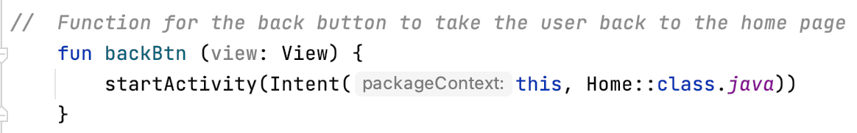

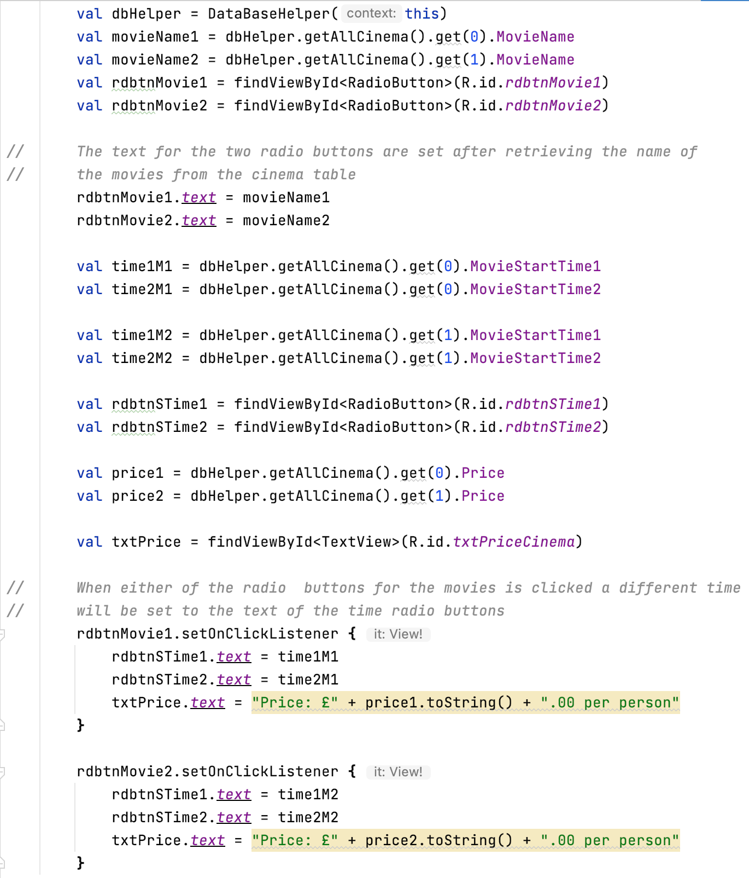Figure 16: The code for the home button

Figure 17: The code within the cinema activity

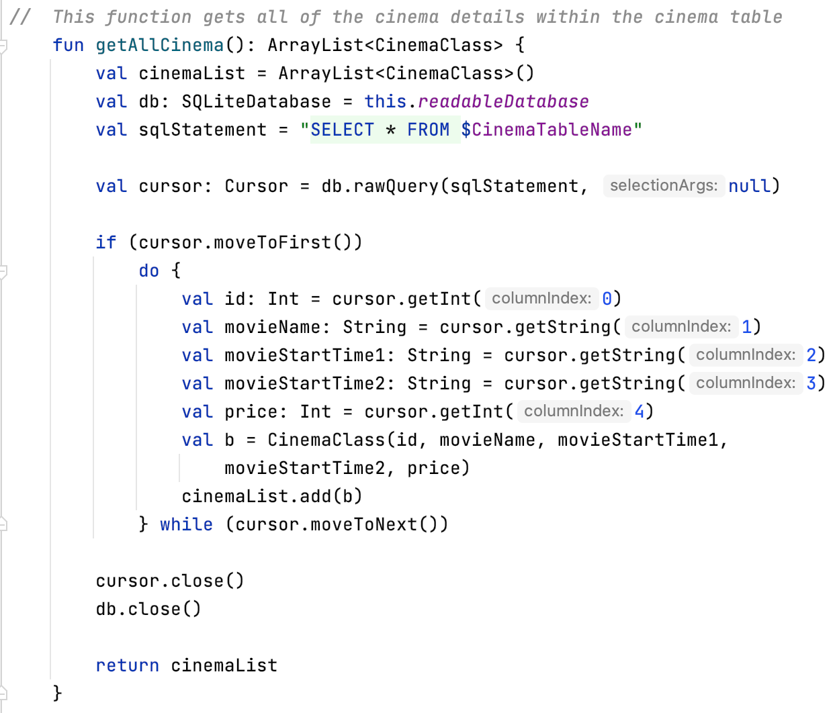Figure 18: The getAllCinema function in the database helper

Figure 19, below, is the function for the confirm button and when the button is clicked the code within the function will run. The first part of the code stores the user’s options in variables so that they can be used and added to the database later on. In this example, the movie name, show time, price, date and number of people. Depending on which of the movie radio buttons have been checked the movie name and the price of the movie will be saved into their own variables which will be used later on. After that, the date and the number of people that the user enters will be stored in their own variables as well. To get the users email, the userLogged table is accessed via the database helper and the last row of data retrieved which is then saved in its own variable. For the validation, if any of the fields have not been completed, the user will be told that they need to complete all of the sections (see figure 21). If all of the fields have been completed, the next part of the code calculates the total price for the booking, this simply takes the number of people the user has entered and times it by the price of their option. Using the addConfrimDetails function within the database helper (see figure 20), will allow data to be added to the booking details table in the database. Each of the variables that have been created earlier with the options saved into the variables are then used within the brackets after addConfirmDetails. The variables are entered in the order of the columns within the booking details table to ensure that the right information if being saved in the right columns in the table. The columns that are not needed for the current activity have a null value in their place. For example, as the user is booking an activity, any of the columns that require transport information have been set to a null value. If the details have been added to the database the next part of the code will run which is the alert dialog builder. This part of the code will display a dialog with the total price of the booking (figure 15), including a “Confirm” and “Cancel” button. If the user clicks “Cancel”, the dialog will simply close. If the user would like to continue with their booking and click the “Confirm” button, the user will have successfully created their booking and will be taken to the confirmation page. If the details have not been added to the database the user will be told to try again and as mentioned, if any fields are not completed the user will be told to complete all of the sections.

Figure 19: The confirm button code

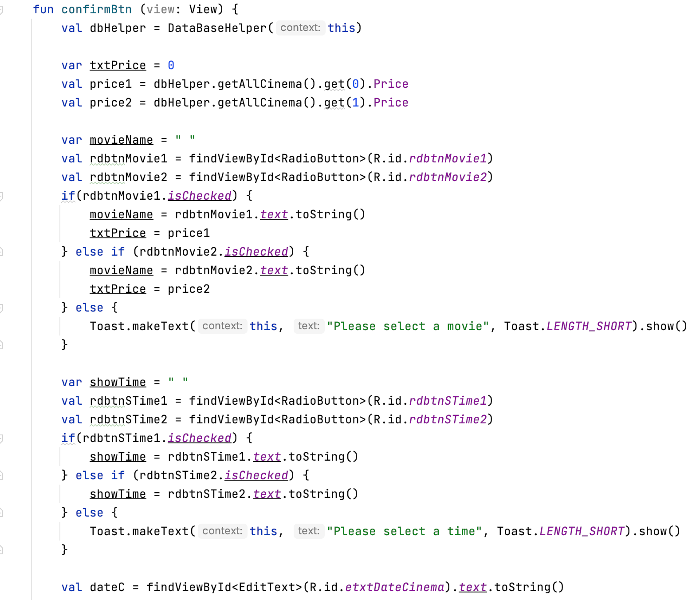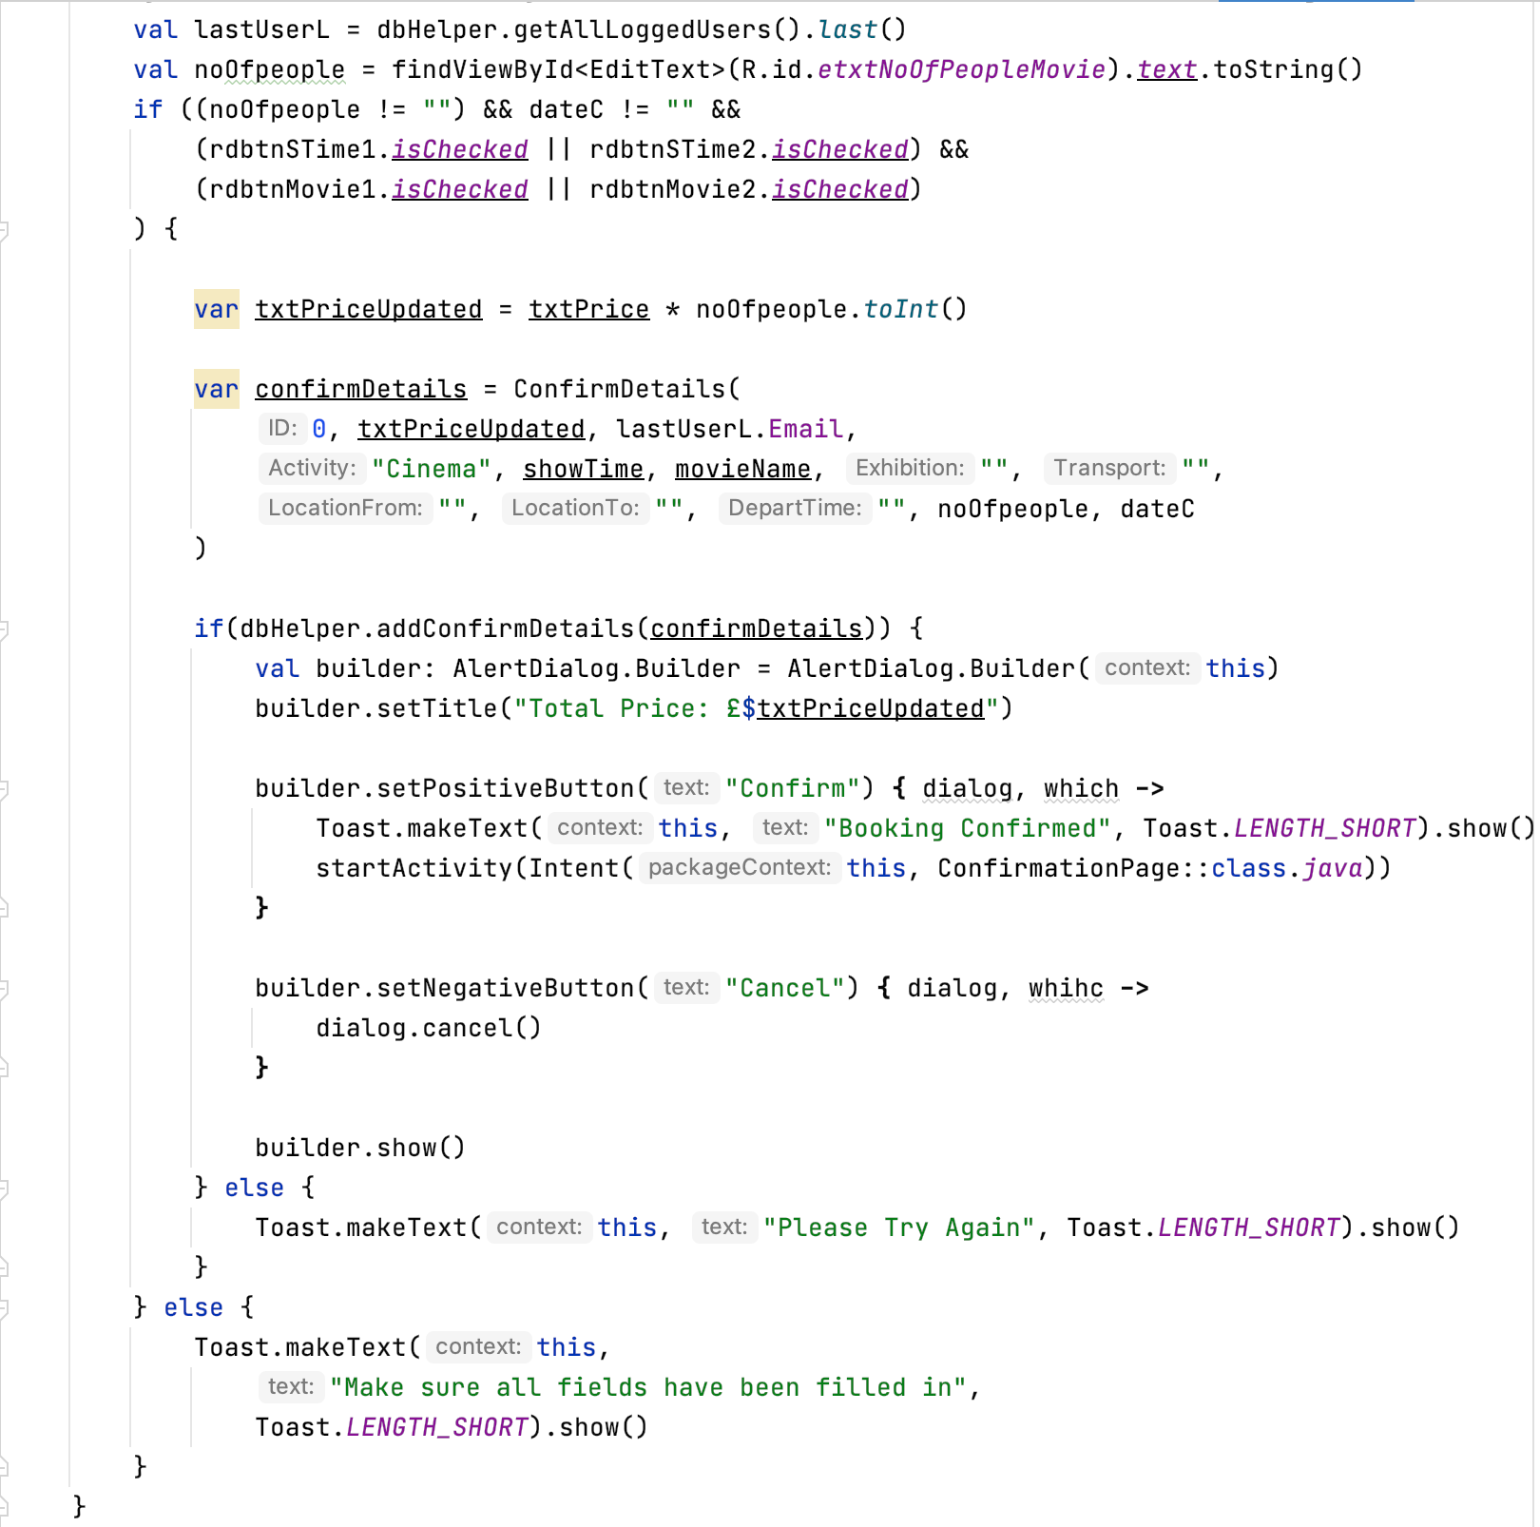

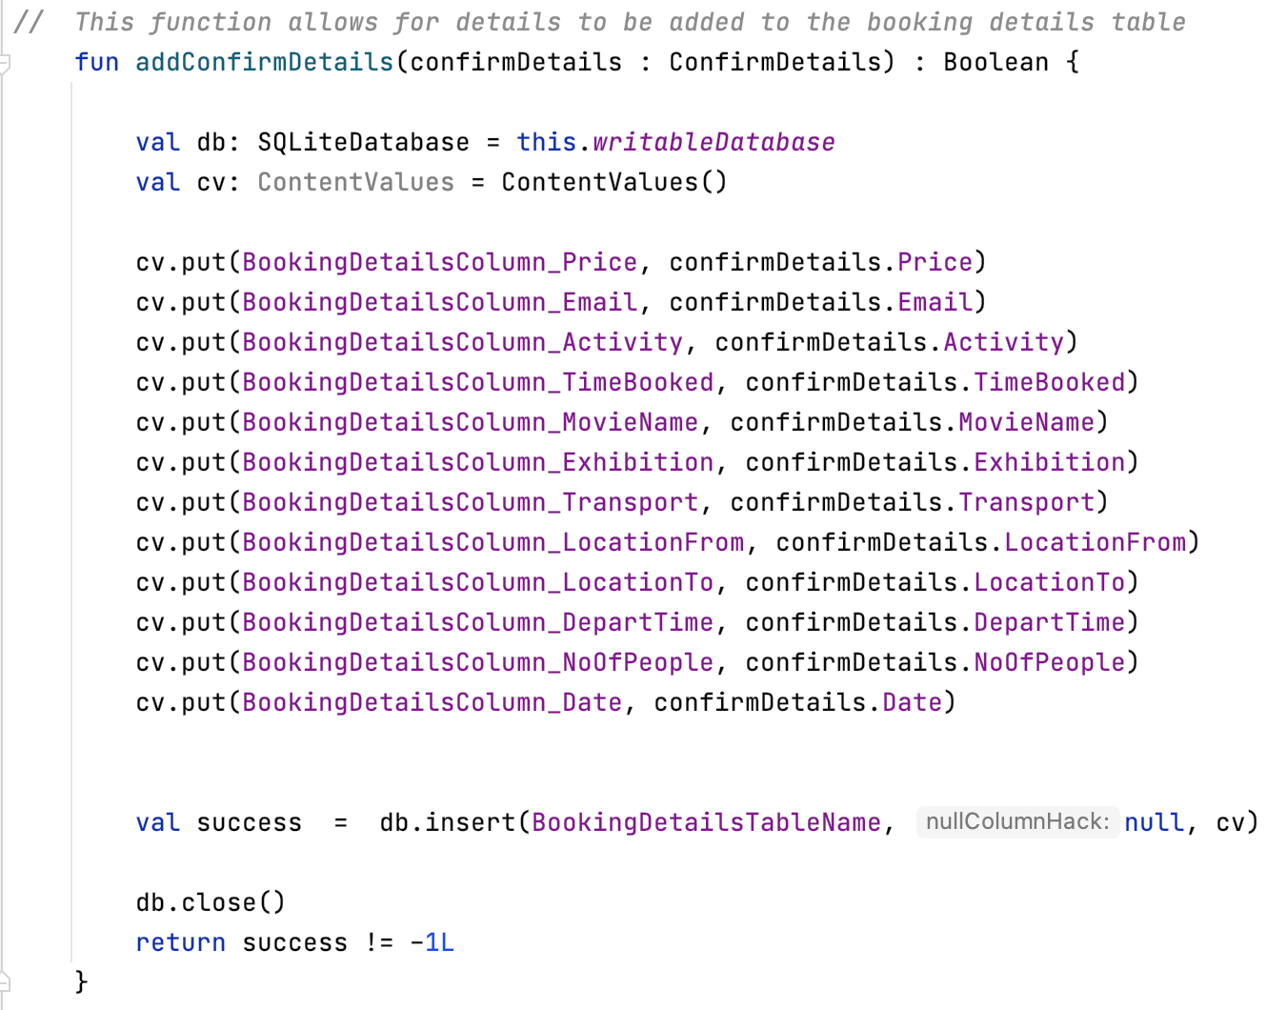

Figure 20: The addConfrimDetails function within the database helper

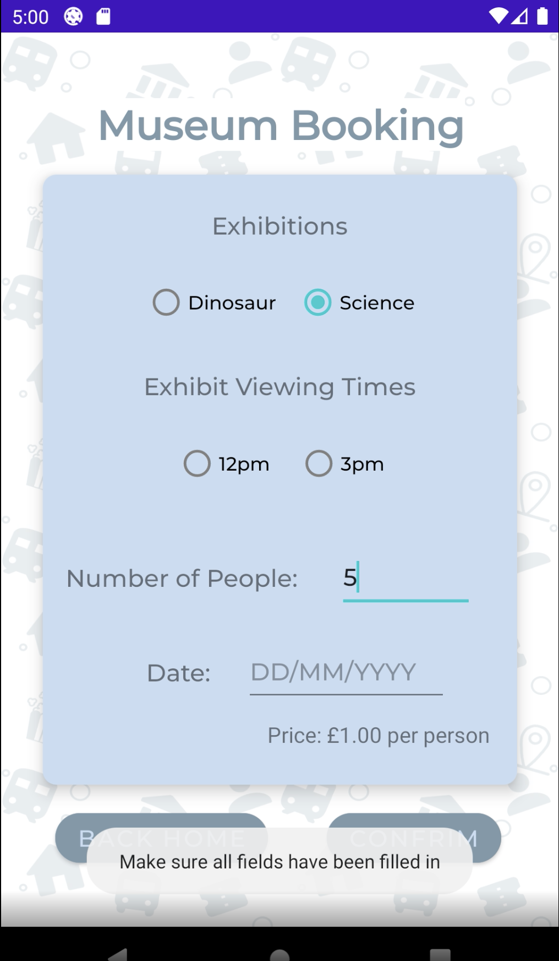Figure 21: The validation for the museum booking page

## 4.4 Confirmation Page

### 4.4.1 Overview

After the user has selected their options and confirmed their booking, they will be taken to the confirmation page. This page essentially retrieves the details for the user’s booking and displays those details for the user’s reference. The reason behind the confirmation page to specifically only retrieve the data that is required for the booking that the user has made and display this to the user. This way the user has evidence that the booking has gone through and also a way to ensure of the details are correct. This again aligns with the objectives within the contract as the page shows that the user has successfully been able to make a booking. The inspiration for this page has come from many different applications and websites, nearly all applications and websites that require a booking or payment to be made, will have a confirmation page with details of the booking or purchased items.

### 4.4.2 Design

The design for the confirmation matches the designs for the previous 4 pages, the cinema, museum, bus and train pages. Again, the reason for this is to keep the application consistent and neat. The colour scheme is again the same, this meets the contract objective that states the colours of the application should be simple and consistent. The text is displayed at a reasonable font size and colour which also matches the objective of the contract that states that all text should be clear and of an appropriate font size. The title of the page is at the top and a short message is included under the title, thanking the user for booking. These two text views have a white background so that the text can still be read against the background of the application. The main details for the users booking is displayed in the centre within a card view. A button is displayed at the button which reads “Back Home”, this will take the user back to the homepage. Figure 22 shows the design of the confirmation page.

Figure 22: The confirmation page

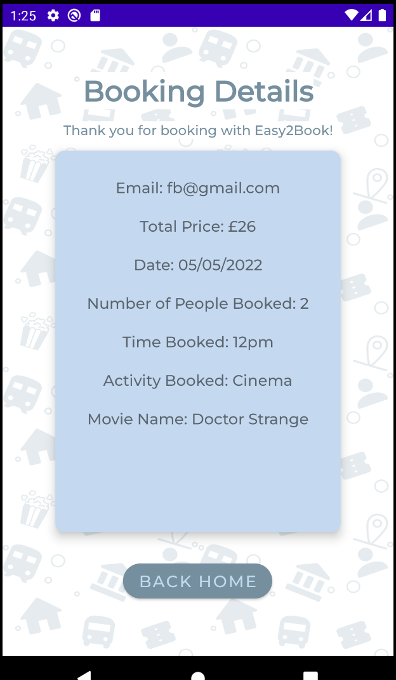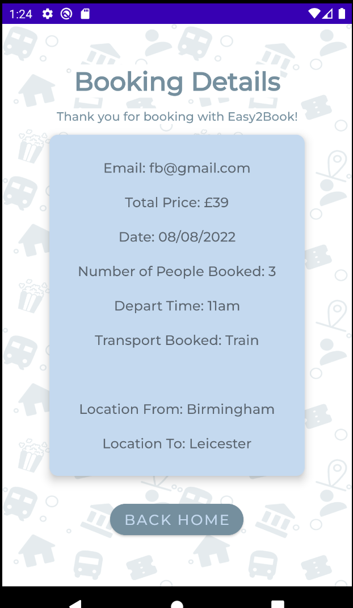

### 4.4.3 Implementation

The first step for the implementation of the confirmation page was to create a function within the database helper that would retrieve all of the data that has been saved within the table. Figure 23 shows the getAllConfirmDetails function within the database helper that retrieves all of the columns and the data within the columns. Within the function, the first line of code creates an array list that will be used for the data. The sqlStatement is then ran through the rawQuery and selects everything within the BookingDetails table in the database. The function goes column by column to retrieve all of the data and then all of the data is added to the array list that was created at the start. When the function is used the result will be the array list with all of the details.

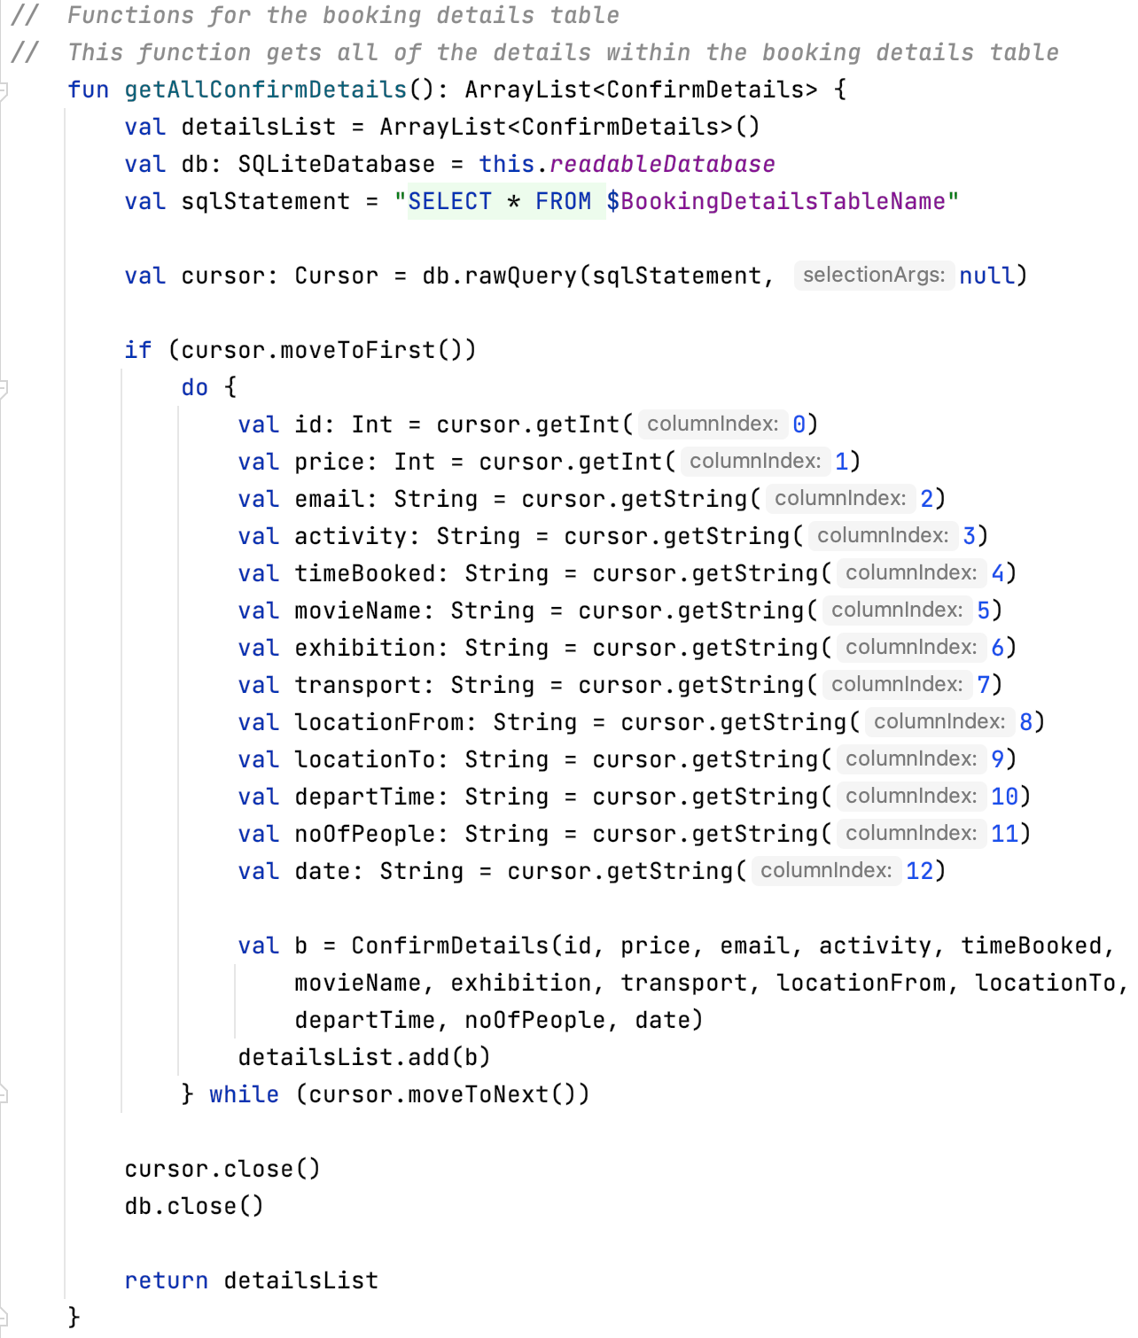On the confirmation page class, the database helper has called so that the getAllConfirmDetails function can be used (see figure 24). A variable is created to retrieve the last row of data from the booking details table, as that is the row of that has just been added when the user made their booking. The next set of variables retrieve all of the text views that are on the xml file, this is so the text can be set to the data required. After the variables, the next bit of code sets the text to the correct bit of data that is needed. Price, email, date and number of people are set as this bit of information does not change no matter what the user has booked. However, depending on what the user has booked, whether it is an activity or transport, different columns from the booking details table are retrieved and set in the correct text views.

Figure 23: The getAllConfirmDetails function within the database helper

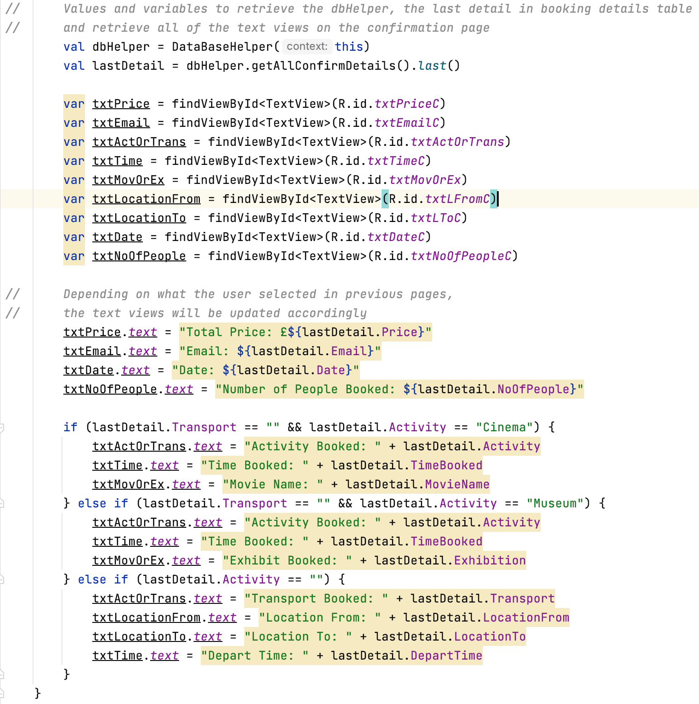Figure 24: The ConfirmationPage class

## 4.5 Login and Signup Page

### 4.5.1 Overview

The last component, in discussion, is the login and signup page. The login and signup page is the first page that will display when the user opens the application. Without an account, the user will not have access to the rest of the application. The reason for an account is mainly for security to ensure people who are not given access will not be able to gain access to other people’s accounts. If the user does not have an account, they are given the change to sign up so they can login with their newly created account. If the user has an existing account, they would simply login and be able to use their account. Also, with an account users’ details will be saved and can be retrieved later on in the application. They can book multiple times using the same account and as the application develops further, the user may be able to view all of the bookings they have made overtime.

### 4.5.2 Design

For the design of the login and signup page, I decided to go with a simple look, like the rest of the application. The main content is displayed in card views with a simple white background, the buttons and the text match the colours of the rest of the application. The text colour has been set to be clear to the users and the font size is big enough so they know what details they need to enter in each of the text boxes. This meets the objective from my contract that states the interface should be clear for users to understand, the font should be clear and the colours of the application should also be consistent. The way this page works is when the “Sign Up”, at the top, is clicked, all the text boxes and items related to the login will be hidden until the user is taken back to the login side. Likewise, when the “Login” is clicked, all of the items that are part of the signup side will be hidden until the user goes back to the signup side. Figure 25 and figure 26, below, shows how this works. For the overall look of the login and signup page, I took inspiration from a couple different videos on YouTube. The YouTubers that I had taken inspiration from are: Solution Code Android [9], Coding with Tea [10] and Coding for Fun [11].

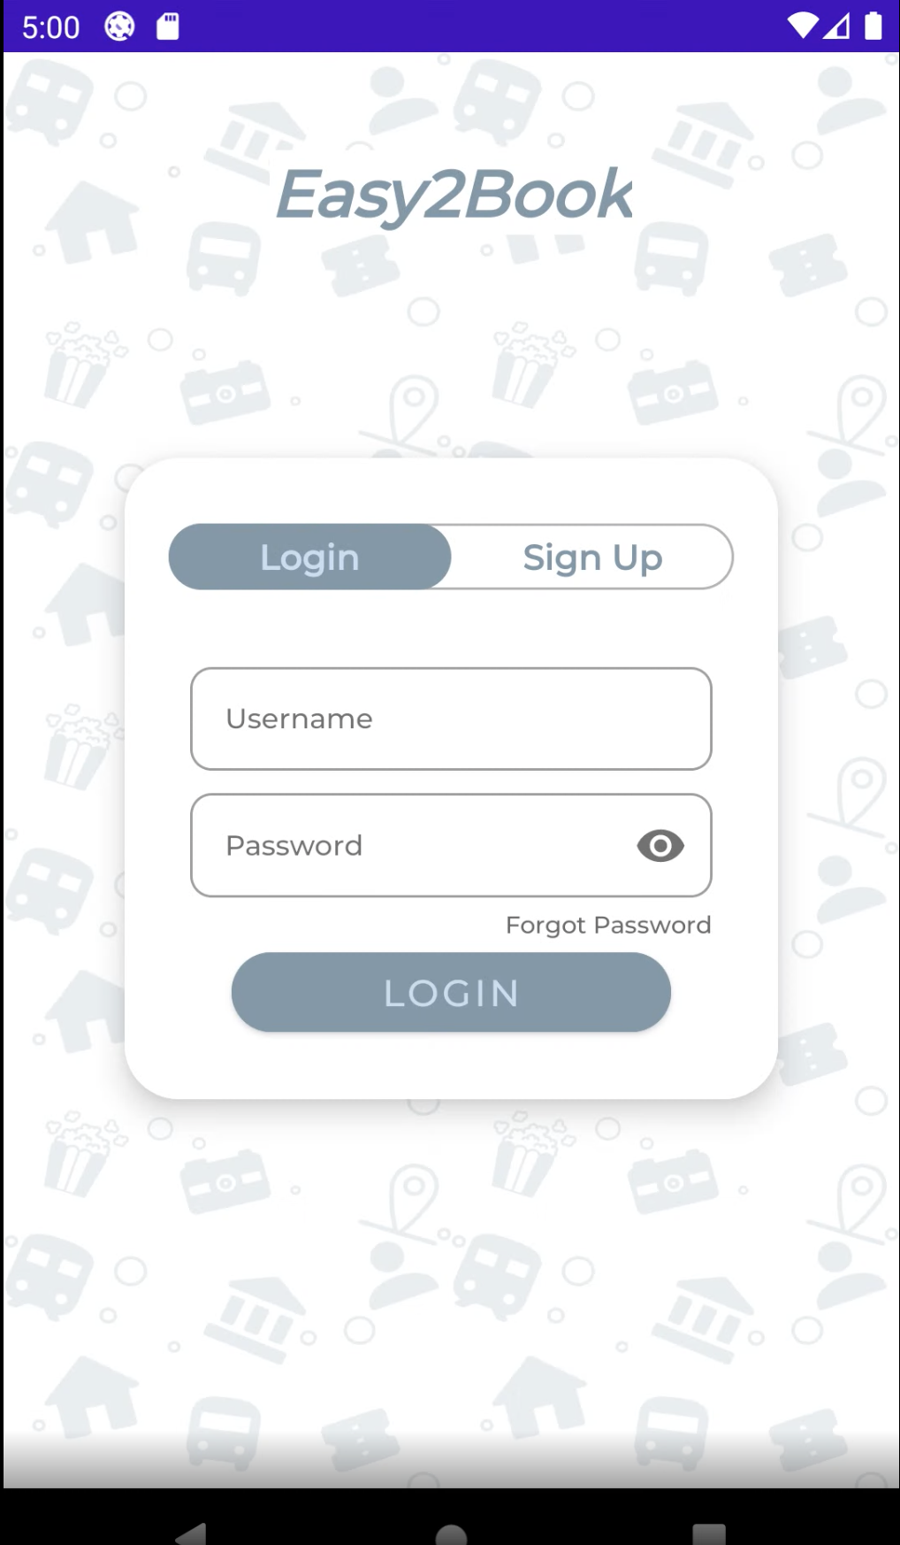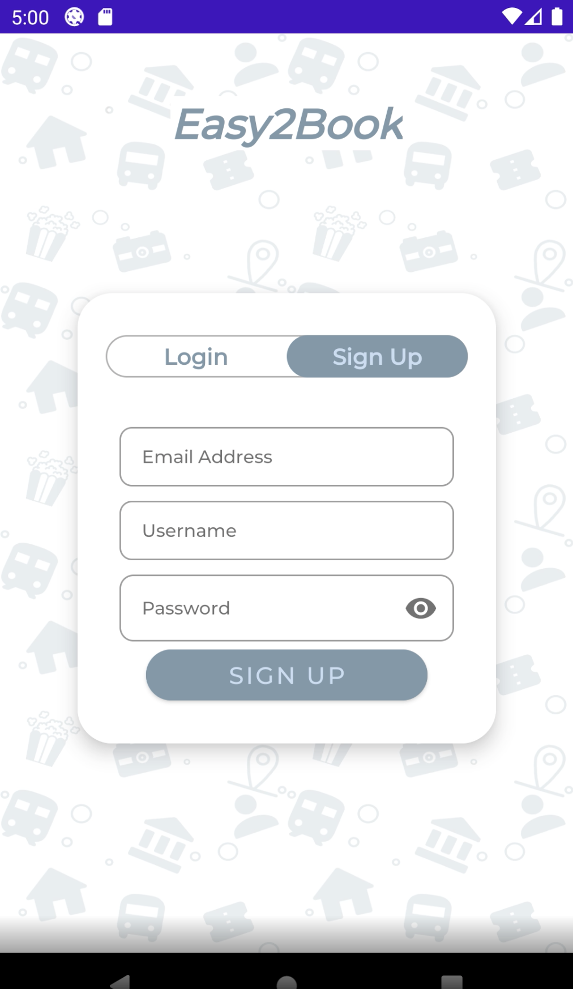

Figure 25: The design of the login and signup page

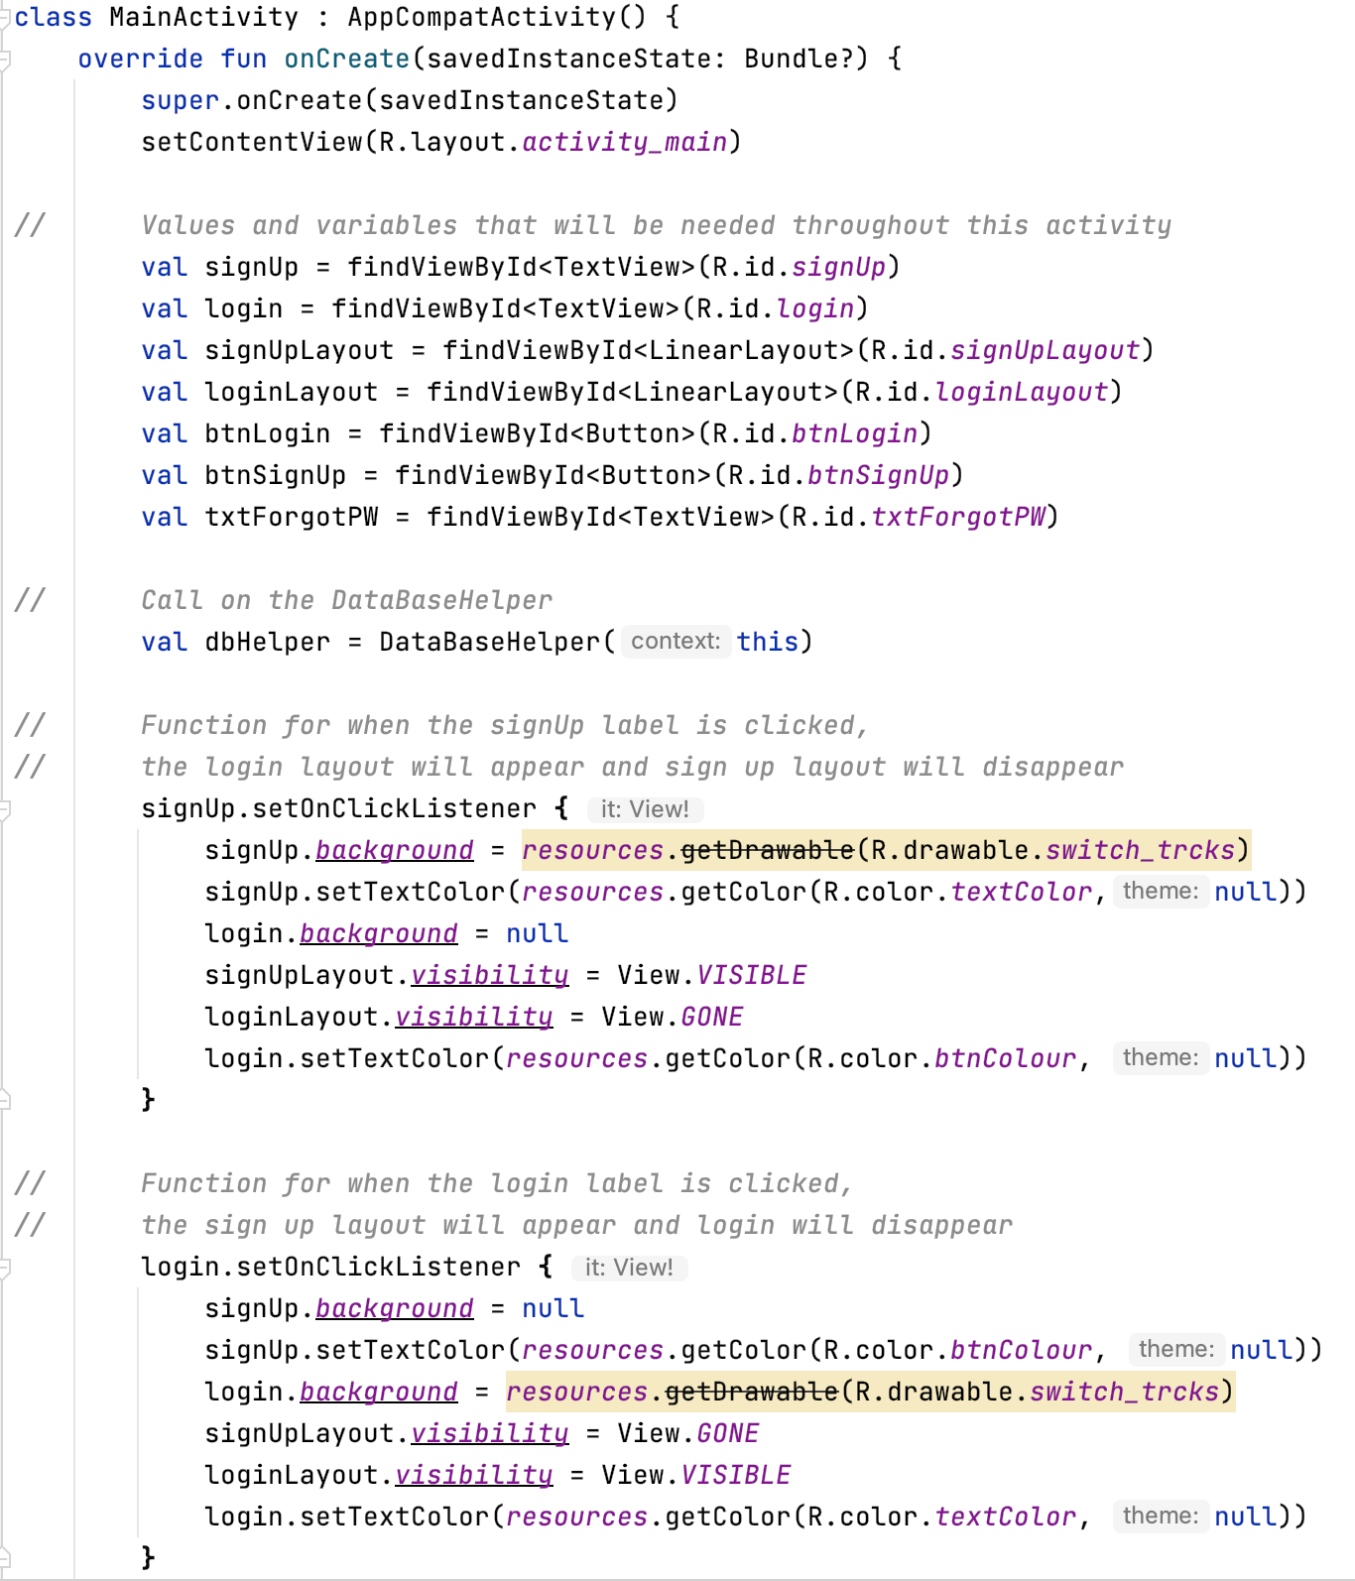Figure 26: The code within the MainActivity

### 4.5.3 Implementation

For the implementation of this page, after the layout has been completed, the first thing was to create functions within the database helper so that I could call on them within the activity. At the start of the database helper, all of the tables were created and inserted. After the tables had been created, the coding for the functions began. The first two functions that were created were for the signup side of the page, see figure 27 for the two functions. The first one, which is called “usernameC”, it essentially checks the username within the user table. It takes the username that has been inputted, within the brackets, and checks it against the usernames within the user table. A variable then stores the usernames within the tables in an array list. The sqlStatement variable is passed into the raw query which will then select all of the data that matches the statement including

the usernameArray. The result is then returned as an Int as the data type for the function is an Int. This function is then used in the “signUpUser” function. Within the second function for the signup, a variable is created at the start which calls on the “usernameC” function and places the user parameter within the brackets, this will represent the users input. In regards to validation, if the result for usernameExists is less than 0 this means that the username does exist and will only return the result of usernameExist. However, if the result is 0, this means the username does not exist and the details that the user has entered will be inputted into the user table. See figure 28, for the signup code within the MainActivity. The “signUpUser” function is called from the database helper and includes the uers details within the bracket. If the name exists, the return will be -3 and the user will be told that the user exists. If the user details do not exist, the return will be a 1, the user will be added to the table and will be sent back to the login to allow them to login, as shown in figure 29.

Figure 27: The two functions for sign up in the database helper

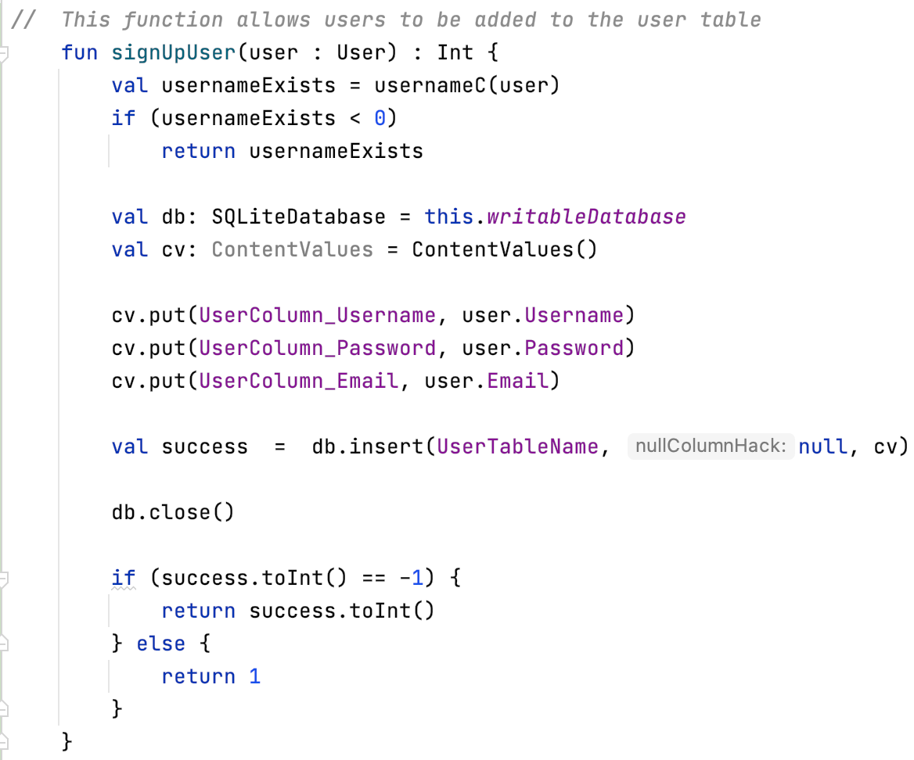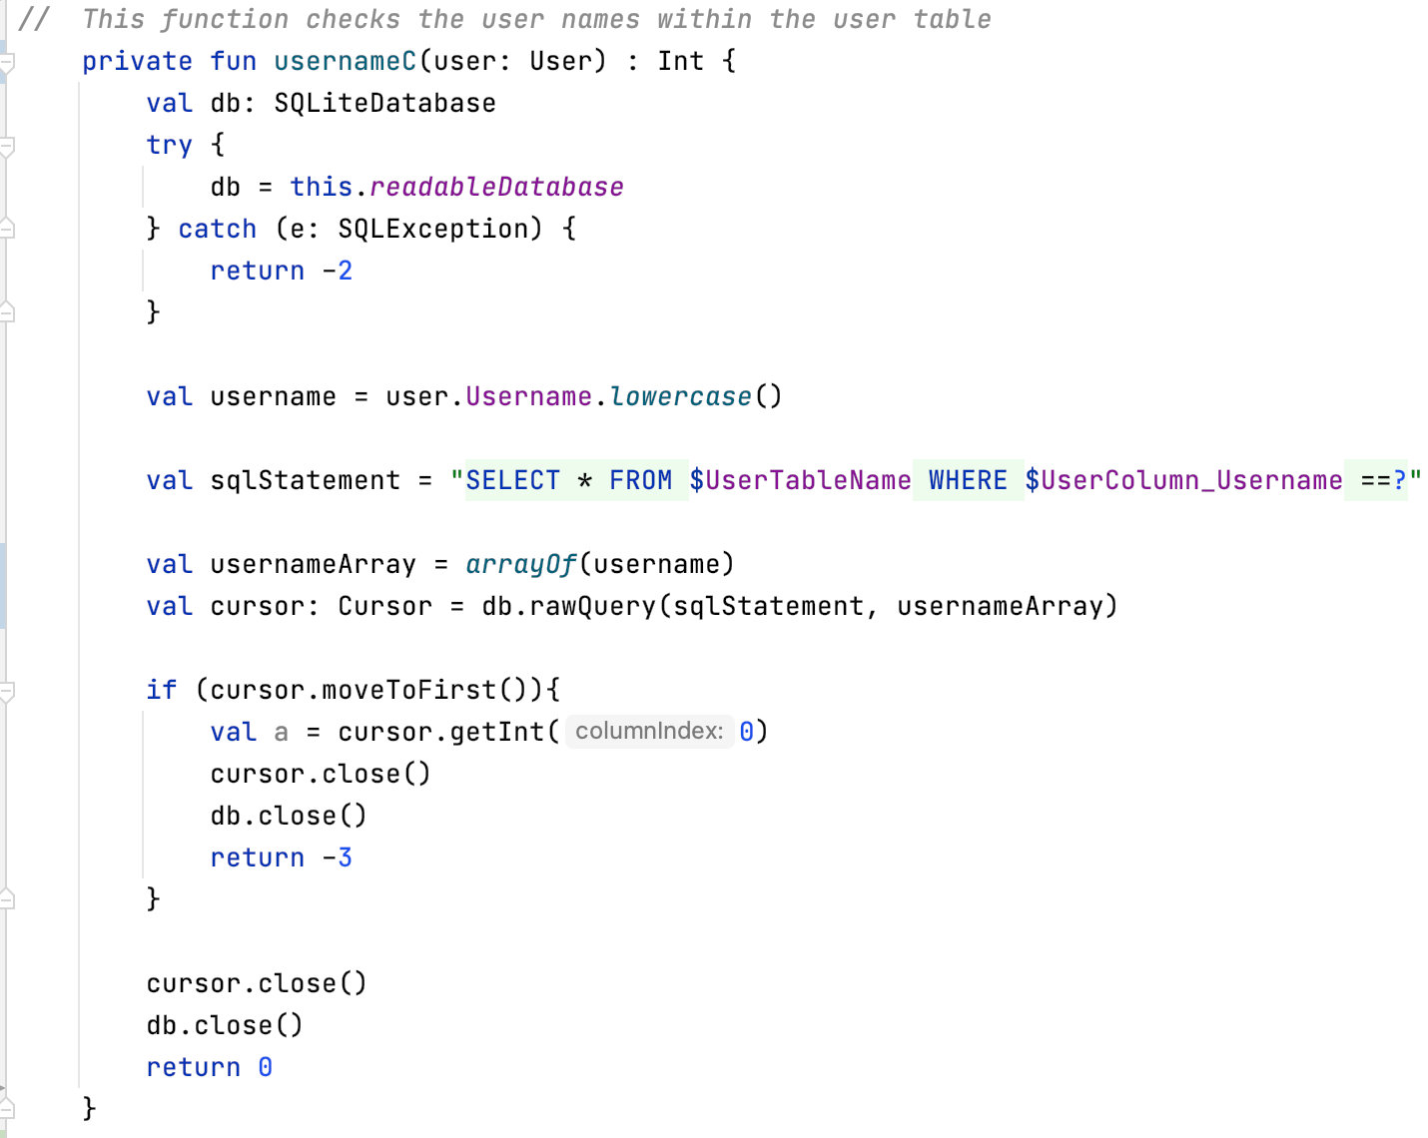

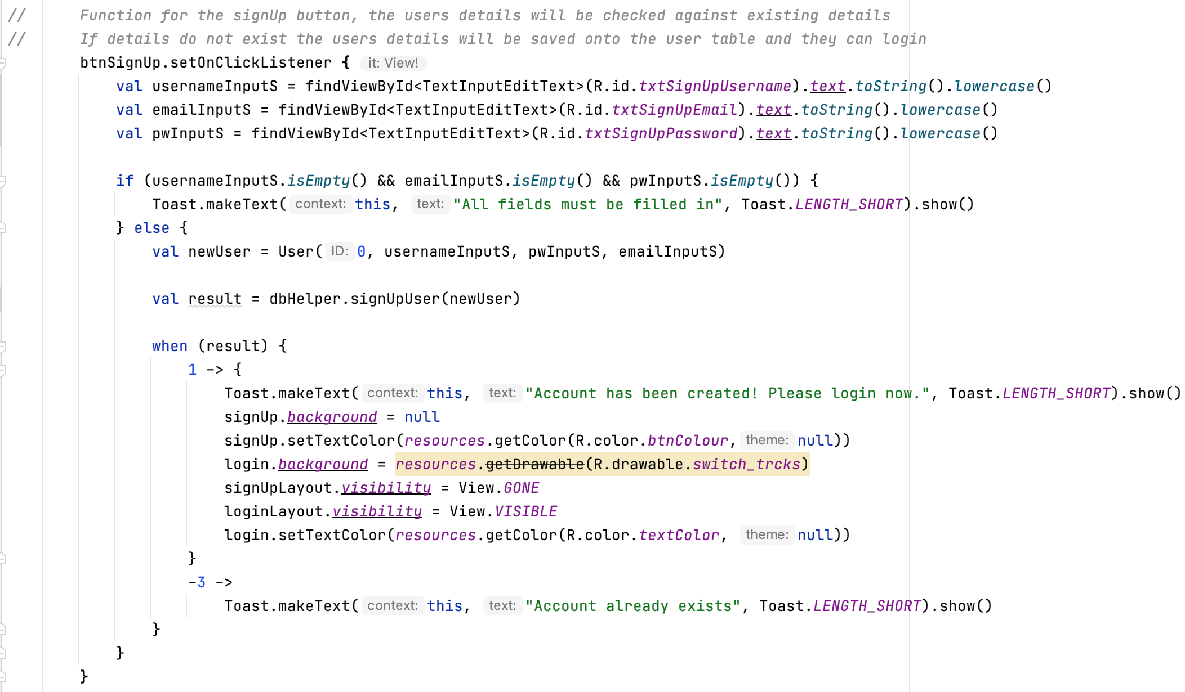

Figure 28: The code for the signup button on the MainActivity.

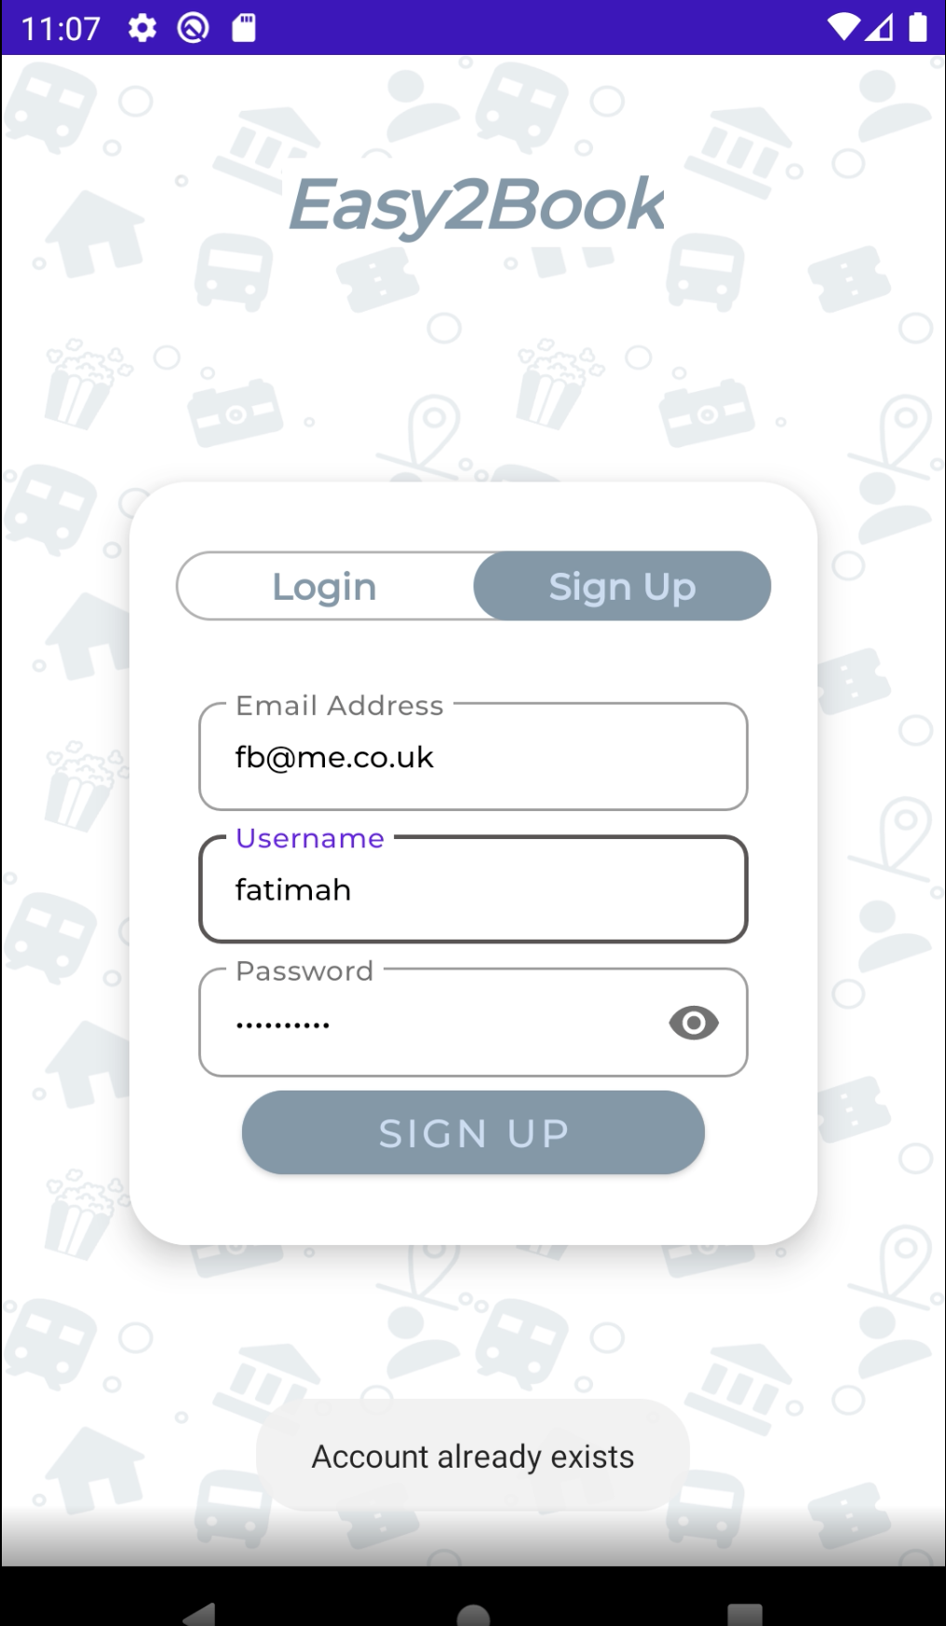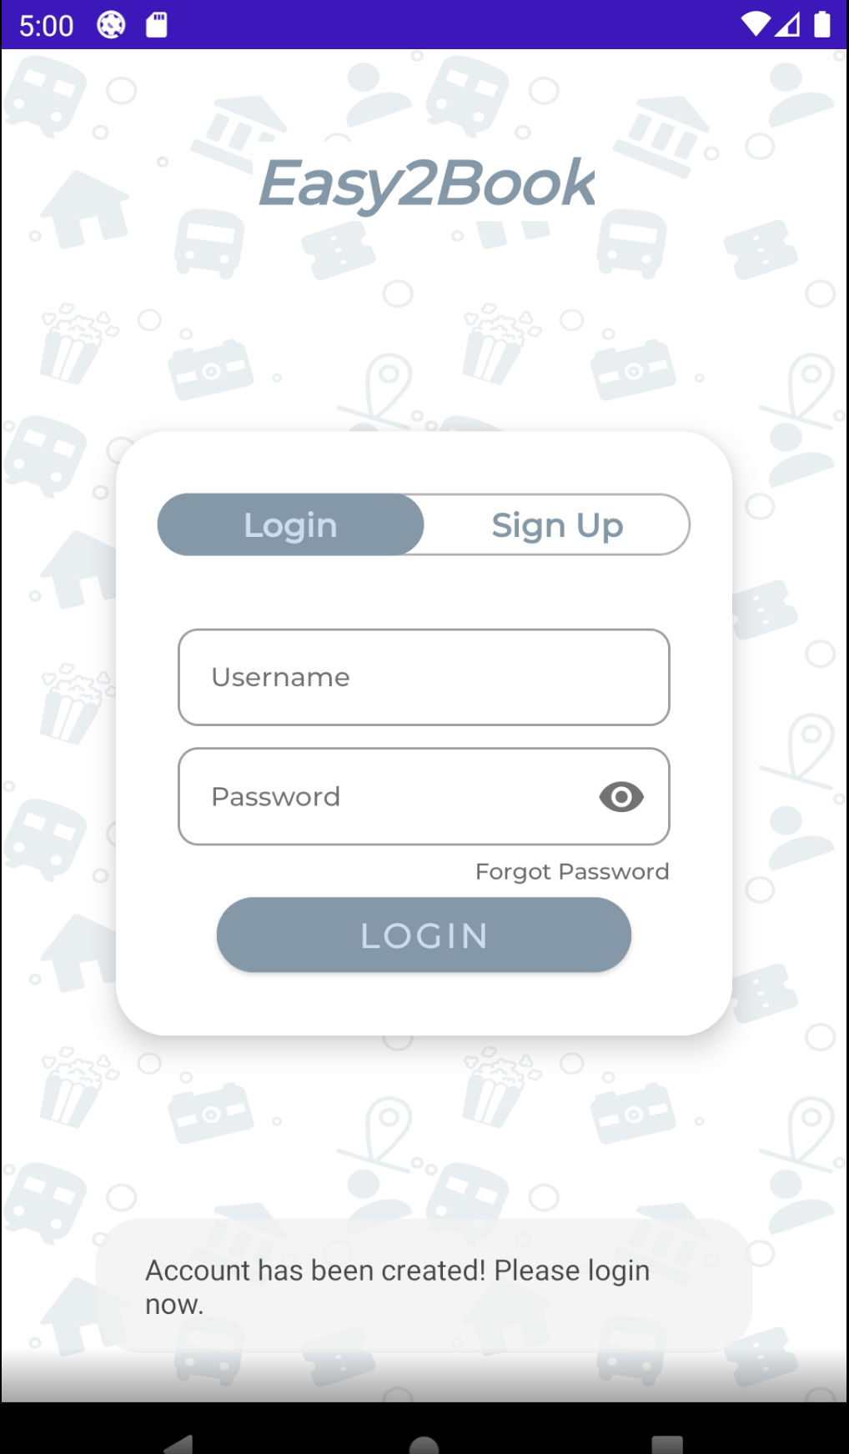

Figure 29: The validation for what happens when the account already exists and what happens when the account does not exist

The third function that was created, in the database helper (see figure 30), is for the login side of the page. The function is called “loginValid” and it takes two string parameters, representing the username and the password that the user will input. What this function does is it goes through all of the usernames and the passwords within the user table, then retrieves the username and password that matches the ones that have been inputted and places them in an array. If the array is empty the result will be false, whereas, if the array count is more then 0 then the result will be true. Within the MainActivity (see figure 31) the username and password that the user has inputted is retrieved and entered into the brackets as the parameters. It calls on the loginValid function and if the result is false, the user will be told that their details are invalid, as shown in figure 32. If the result is true the user details will be added to a different table so that the details can be retrieved later on in that application and the user will be taken to the home page.

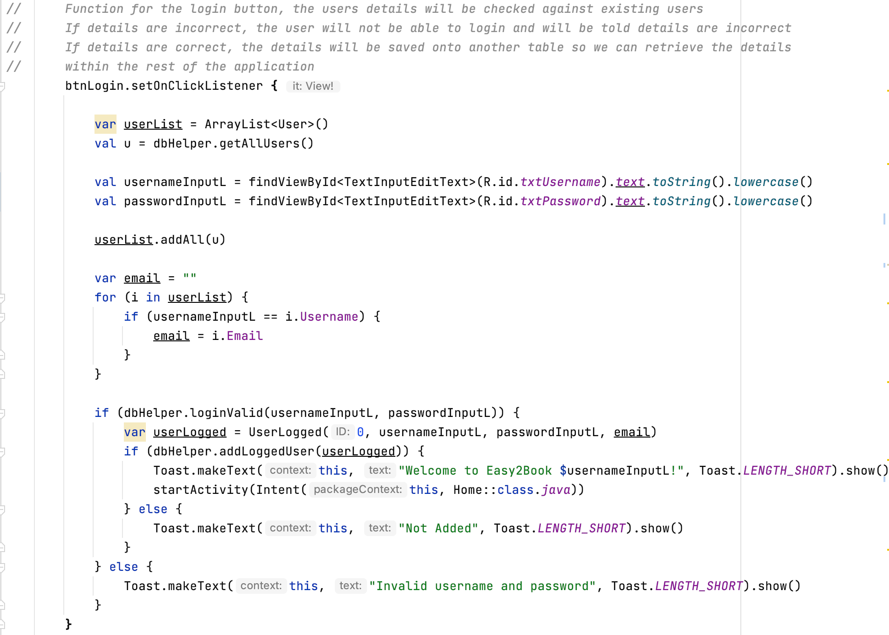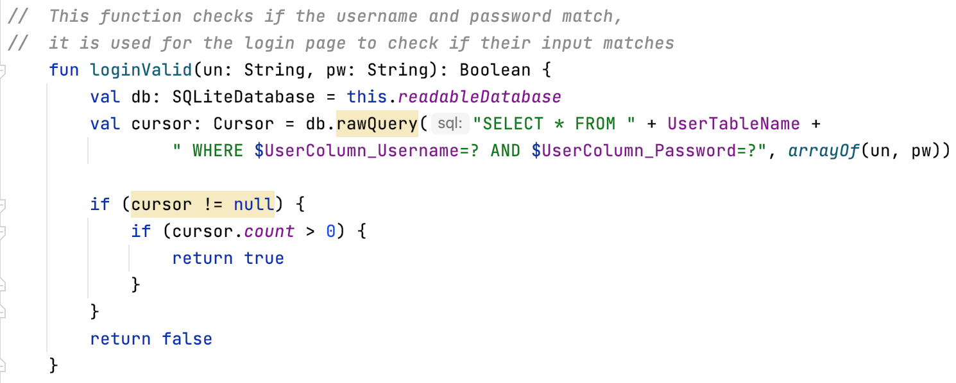Figure 30: The loginValid function from the database helper

Figure 31: The code for the login button on the MainActivity

Figure 32: The validation for when the user details are incorrect and when they are correct

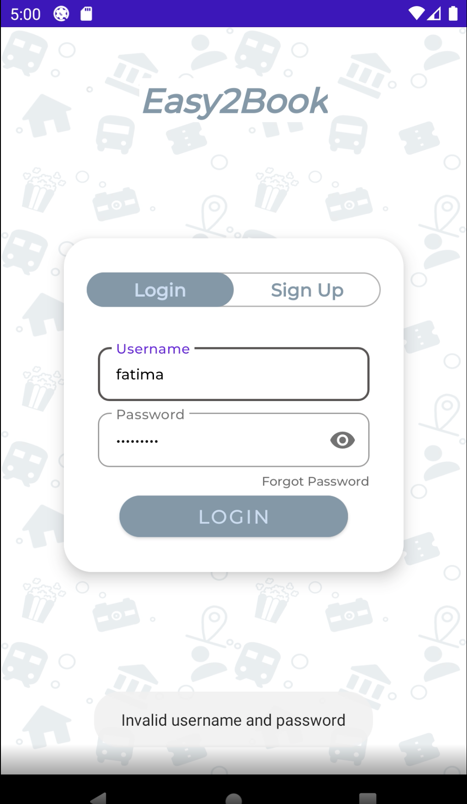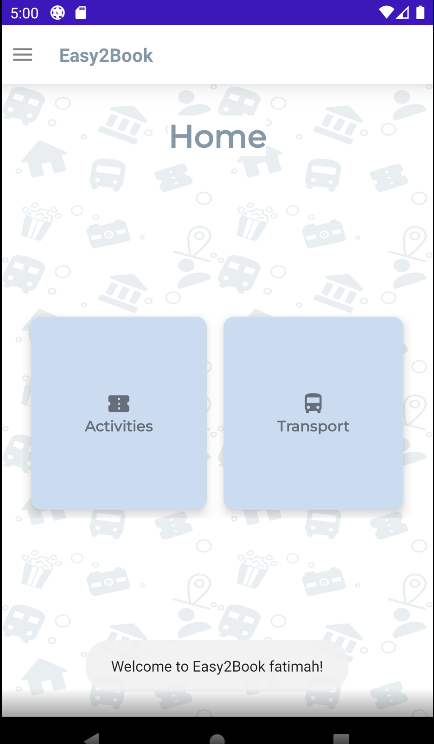

As part of the login side of the page, there is a “Forgot Password” text box and if the user clicks on this, they will be taken back onto the signup side and be told to sign up again. Figure 33, shows the code for the forgot password.

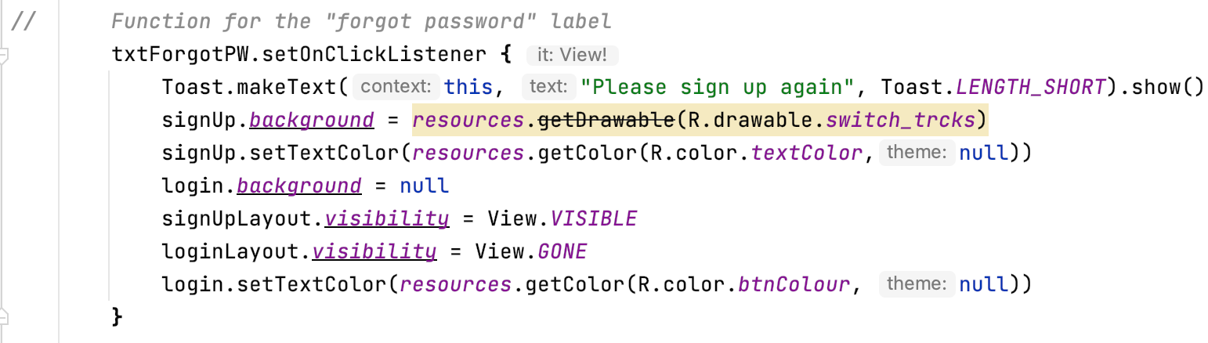Figure 33: The code in the MainActivity for the forgot password

# 5.0 Testing

In relation to the testing phase of this project, testing would be done after the implementation for each of the components was completed. The reason for this is due to the implementation of the Agile in SDLC methodology. With this methodology, the testing usually takes place after the implementation, this allows for changed to be made to the component being tested before moving onto the next component. This was it the application is more efficient as one component is fully completed with no errors before moving onto the next component.

For the testing strategy, as mentioned in the first deliverable, I used the usability testing strategy and the black box testing strategy.

With the usability testing strategy, real users are used to test the application by following certain tasks that are given to them, while the developer is overlooking them test the application. An example of a task given to the users, using the Easy2Book application, could be to ‘Navigate to the Activity page via the navigation drawer’. Any issues are noted down and will be considered before moving onto the next component.

With the black box testing strategy, the focus is on software requirements, it focuses on the input and the output of the application. The developer would come up with test cases that would have certain inputs and certain outputs. An example with Easy2Book would be, the input would be to click the ‘Activity’ button on the home page and the output should be that the activity page is loaded after clicking the button. If any of the inputs results in a different output, this will be noted down.

The test plan (see Appendix 1), will list all of the tasks that had been completed as part of the testing phase and the outcome.

# 6.0 Further Development

In regards to the maintenance and further development of this application. Although the application is developed to function the way it was created to function, there is definitely space for some further development. One aspect of the application that can be developed on, could be to provide the user with more options for the activities and transport. This will allow for users to have more of a variety and not be narrowed down to a couple options. There could also be more options added to each of the pages, in the sense that there could be more times to select from or for example more movies to choose from. Another possible suggestion could be for users to pay using the application before getting their confirmation. Even if there aren’t many activities to select from, at least the user will be able to have a bigger selection for each of the activities or transport.

Additionally, an admin section can be added to the application. The admin section will only be able to be accessed by the admins using a username and password. With the admin section, the admin could be able to add more activities and transport, including more options for each of the activities and transport. Another suggestion would be to include the user’s details in the header of the navigation, I was originally going to implement this. However, it did not work with the application so in later versions, this can be implemented. Also, within the profile page, a section to allow the user to see all of the past bookings they have made can be implemented into the application.

# 7.0 Critical Analysis and Reflection

Overall, I believe I have developed a great application that meets all of the objectives that were included in the contract, at the start of the project. While completing this project, the initial documents had played a huge part in the planning of the application and the overall outcome of the application. The Easy2Book application and the process of the development of the application meets the ethical review and global checklist forms that were also filled out at the start of the project. For example, one of the points was regarding copyright issues, all of the images and vector asses used are free to use or have been taken from the Android Studio software. The background was created by myself so there are no issues of copyright within my application.

During the development of the application, I had noticed the software, Android Studio, can be quite temperamental which made it slightly difficult to work with at times. Despite this, I still managed to work with it and complete the application to the best of my ability and the development process did run quite smoothly minus a couple issues. Using the emulator provided by Android Studio, the testing phase of the project ran smoothly as I was able to easily test each of the components. As I was implementing the Agile in SDLC methodology, I was testing each of the components after the implementation had been completed and each time the testing ran as expected. Due to the project changing slightly, during the implementation stage, changed were made to the UML diagram and ERD diagram to account for the changed made to the application (see Appendix 2 and 3).

The overall concept used for the project was OOP (Object Oriented Programming) and the architecture of the code was the MVC architecture (Model, View, Controller). Using the MVC architecture helped me structure the fragments, activities and classes within Android Studio, including ensuring that the application is implemented in an efficient way.

While completing the project, I had noticed my time management and scheduling did not match up. With the initial Gantt chart, I had created, I noticed I had given myself some unrealistic timelines not realising how long each of the phases would take in reality. Some tasks would take me a lot longer to complete and some tasks would not take me as long as what I had noted down. This resulted in me being slightly stressed and worried about the completion of my project. The meetings that I had with my supervisor were also not predetermined, I would meet with my supervisor as and when needed which was not as efficient as I could not have noted this down in the Gantt chart beforehand. As I had implemented the Agile in SDLC methodology, timing was a huge part of the methodology and during the completion of this project, I did not completely stick to the initial project plan. Despite this, I was able to complete the project with ample time before the deadline. Additionally, a little bit more research and planning could have been done beforehand. Although I had researched and planned before starting the project, as it was it was my first large project and I was quite overwhelmed, I underestimated how much research and planning needed to be done. What I would do next time is I would try to ensure I have done enough research and create a clear plan of what I will be doing for each stage in the process, including what each of the components in my project will include. For example, I will try and plan what functions will be needed and how I will be completing those functions. This would possibly help me feel less overwhelmed when it comes to the next project.

Learning from this, for the next project, I will make sure to create a project plan with realistic timelines. To do that I would also need to set aside a good amount of time to allow myself to research and create a well detailed plan for the project. Using the research, I will make sure to thoroughly think about each of the phases within the project and set a realistic timeline for each phase and component. This will help with the project plan and will also help ensure I stick to the timelines of the plan. As mentioned, the methodology I decided to implement was the Agile in SDLC, where timing plays a huge role. In hindsight, I would create a project plan based on all of the research I have done, making sure to strictly stay within the timelines and complete each of the tasks at the right time.

# 8.0 Conclusion

To conclude, I have discussed all of the details for the project I have completed. The overall process of this project has been a great experience for me as it is the first time completing a large project, like this one. I have learnt many new skills and developed on existing skills. I am happy with the outcome of the project and the application I have created. I managed to create a mobile booking application that meets all of the objectives that have been mentioned within the contract that was created at the start of the project. The application also meets all of the requirements from the other two starting documents which were the ethical review and the global checklist. Each of the components and all of the features within the application have come together nicely to create the mobile booking application.

While completing the project a few features and parts of the application did change from the initial plan of the application. However, these changed do not take away from the overall application, some of the changed only enhance the application more. Other changed may have not enhanced the application but as mentioned it did not take away from the functionality of the application. For example, one part of my application that did not go as planned was the username being displayed in the navigation drawer header. I tried many different ways and all of the ways I had tried would make the application crash so I decided to display the name of the application instead. This does take away anything from the application and does not change any major components, the application still meets all of the objectives mentioned within the contract and the navigation drawer looks just as nice with the name of the application. However, this can be taken into account for further development of the application in the future. Another issue I ran into while implementing was the fragment management. I had not worked with fragments before this project and was not sure how to navigate from one fragment to another. I spent quite a long time researching and emailing lecturers to help me find a way and luckily, I did find a way to navigate between fragments. This helped me become familiar with fragments because while doing research I had come across a lot of information relating to fragments. I had never used fragments before but after this project I am quite familiar with them.

I used the coding language, Kotlin, to implement the application and I am glad I did. I was quite wary at the start as I was very new to the language, however, I managed to use the language with little to no issues. Using Android Studio has been a bit of a roller coaster experience because the application can be quite temperamental, as mentioned above. However, I am glad I decided to use the software for my project. I already had some existing experience with Android Studio and Kotlin by studying the module Mobile Application Development which did help me with the completion of the application. By using it for my project as well it helped further build on my skills and knowledge on the software and the language.

**Word Count:** 7943

# 9.0 References

1. Chaudhary L. (2019). *“Agile in SDLC | Characteristics and Functionality of Agile in SDLC”.* *EDUCBA*. Available at: <https://www.educba.com/agile-in-sdlc/> [Accessed: 18 April 2022]
2. Li, A. (2021). *“Google widley rolls out Play Store navigation and settings redesign on Android”. 9to5Google.* Available at: <https://9to5google.com/2021/04/07/google-play-store-redesign/> [Accessed: 18 April 2022]
3. Faitotoro. (2022). *“Travel Doodle Seamless Pattern Background Vector Image”. VectorStock.* Available at: <https://www.vectorstock.com/royalty-free-vector/travel-doodle-seamless-pattern-background-vector-15878699> [Accessed: 15 April 2022]
4. Rohila S. (2020). *“How to move from one fragment to another fragment on click of an ImageView in Android?”. Stack Overflow.* Available at: <https://stackoverflow.com/questions/23212162/how-to-move-from-one-fragment-to-another-fragment-on-click-of-an-imageview-in-an> [Accessed: 21 December 2021]
5. Babu E M. (2021). *“How can I access getSupportFragmentManager() in a fragment?”. Stack Overflow.* Availbale at: <https://stackoverflow.com/questions/20237531/how-can-i-access-getsupportfragmentmanager-in-a-fragment>
6. Vaatie E. (2021), *“How to Code a Navigation Drawer for an Andorid App”. Envatotuts+.* Available at: <https://code.tutsplus.com/tutorials/how-to-code-a-navigation-drawer-in-an-android-app--cms-30263> [Acessed: 19 December 2021]
7. Foxandroid. (2021). *“Navigation Drawer using kotlin in Android Studio || Slidable Menu with Navigation Drawer || Kotlin”. YouTube.* Available at: <https://youtu.be/zQh-QGGKPw0> [Accessed: 19 December 2021]
8. SmallAcademy. (2021). *“Implement Navigation Drawer in Kotlin | Android App Development Tutorial for Beginners”. Youtube.* Availbale at: <https://youtu.be/l-jdSOUpSIA> [Acessed: 19 December 2021]
9. Solution Code Android. (2021). *“Android Studio login page Ui deisgn in Android kotlin/Andorid login screen deisgn”. YouTube.* Available at: <https://youtu.be/4lwfvj9EL4g> [Accessed: 19 February 2022]
10. Coding With Tea. (2020). *“Android Login Screen | Login Android Studio | Android Studio”. YouTube.* Available at: <https://youtu.be/ayKMfVt2Sg4> [Acessed: 19 February 2022]
11. Coding For Fun. (2020) *“Modern Login UI Android Studio – kotlin”. YouTube.* Available at: <https://youtu.be/zl0_ZbA4vEA> [Accessed: 19 February 2022]
12. UiLover Android. (2022). *“Xd Android studio profile page || profile ui app || Profile Android Studio”. YouTube.* Available at: <https://youtu.be/r3ih0O2Nwxw> [Accessed: 21 February 2022]
13. Solution Code Android. (2021). *“Profile UI design in android studio/how to design the profile for andorid app using xml in android”. YouTube.* Available at: <https://youtu.be/BCZUdl3CXKM> [Accessed: 21 February 2022]

# 

# 10.0 Appendices

## Appendix 1 – Testing

|  |  |  |  |  |
| --- | --- | --- | --- | --- |
| Test ID | Test Objective | Test Description | Expected Results | Actual Results |
| T001 | Test the signup label to see if the user is taken to the signup. | The user will locate the label near the top of the page, under the title, next to the login label, and click on it. | The signup content should appear on the screen and the login content should be invisible. | Pass |
| T002 | Test the login label to see if the user is taken back to the login. | The user will locate the label near the top of the page, under the title, next to the signup label and click on it. | The login content should appear on the screen and the signup content should be invisible. | Pass |
| T003 | Test the login button to see if it functions correctly and loads the home page. | The user will enter their details correctly and click on the login button. | If the fields are not empty and the user’s details are correct, the home page will load. | Pass |
| T004 | Test if the validation works for the login page, when the user details are incorrect. | The user will enter their details in incorrectly and click on the button. | The toast message will appear on the screen letting the user know their details are incorrect. | Pass |
| T005 | Test if the signup button functions as expected and loads the login. | The user will enter their details into the fields and then click on the signup button. | If the details do not exist the user will be taken to the login to allow them to login. | Pass |
| T006 | Test if the validation works for the signup page, when the username already exists. | The user will enter an already existing username into the field. | The toast message will appear on the screen letting the user know that the username already exists. | Pass |
| T007 | Test the navigation drawer, check if the navigation drawer opens with a swipe to the right. | The navigation drawer is located on the left of the application and the user can swipe right to open the navigation drawer. | The user will swipe right and the navigation drawer will open. | Pass |
| T008 | Test the navigation drawer, check if the navigation drawer opens by clicking on the hamburger image view. | The navigation drawer is located on the left of the application and there is a hamburger image view at the top left of the page that will open the navigation drawer. | The user will click on the hamburger image view and the navigation drawer will open. | Pass |
| T009 | Test if the ‘Home’ tab in the navigation drawer works as expected. | When the user has opened the navigation drawer there will be a few tabs for them to click on, one of them being the ‘Home’ tab. | When the navigation drawer is open and the user clicks on the ‘Home’ tab, the ‘Home’ page should load. | Pass |
| T010 | Test if the ‘Activity’ tab in the navigation drawer works as expected. | When the user has opened the navigation drawer there will be a few tabs for them to click on, one of them being the ‘Activity’ tab. | When the navigation drawer is open and the user clicks on the ‘Activity’ tab, the ‘Activity’ page should load. | Pass |
| T011 | Test if the ‘Transport’ tab in the navigation drawer works as expected. | When the user has opened the navigation drawer there will be a few tabs for them to click on, one of them being the ‘Transport’ tab. | When the navigation drawer is open and the user clicks on the ‘Transport’ tab, the ‘Transport’ page should load. | Pass |
| T012 | Test if the ‘Profile’ tab in the navigation drawer works as expected. | When the user has opened the navigation drawer there will be a few tabs for them to click on, one of them being the ‘Profile’ tab. | When the navigation drawer is open and the user clicks on the ‘Profile’ tab, the ‘Profile’ page should load. | Pass |
| T011 | Test if the ‘Activity’ button, on the home page, functions as expected. | There are two buttons on the home page that the user can select from, one of them being the ‘Activity’ button, the user will locate this button in the middle of the page. | On the home page, when the activity button is clicked, the activity page should load. | Pass |
| T012 | Test if the ‘Transport’ button, on the home page, functions as expected. | There are two buttons on the home page that the user can select from, one of them being the ‘Transport’ button, the user will locate this button in the middle of the page. | On the home page, when the transport button is clicked, the transport page should load. | Pass |
| T013 | Test if the ‘Cinema’ button, on the activity page, functions as expected. | There are two buttons on the activity page that the user can select from. One of those buttons being the ‘Cinema’ button, the user will locate this button in the middle of the page. | On the activity page, the user will click the cinema button and the cinema page will load. | Pass |
| T014 | Test if the ‘Museum’ button, on the activity page, functions as expected. | There are two buttons on the activity page that the user can select from. One of those buttons being the ‘Museum’ button, the user will locate this button in the middle of the page. | On the activity page, the user will click the museum button and the museum page will load. | Pass |
| T015 | Test if the ‘Bus’ button, on the transport page, functions as expected. | There are two buttons on the transport page that the user can select from. One of those buttons being the ‘Bus’ button, the user will locate this button in the middle of the page. | On the transport page, the user will click the bus button and the bus page will load. | Pass |
| T016 | Test if the ‘Train’ button, on the transport page, functions as expected. | There are two buttons on the transport page that the user can select from. One of those buttons being the ‘Train’ button, the user will locate this button in the middle of the page. | On the transport page, the user will click the train button and the train page will load. | Pass |
| T017 | Test if the user can select the movie they would like to book, including adding the number of people being booked, the time and the date they would like to book for. | On the cinema page, the user will be able to locate the options, in the middle of the page. They can select from two movies and two showtimes they would like to book for. They will be able to enter the date they would like to book and the number of people they want to book for. | The user will select their movie and the time they would like to book, on the cinema page. The user will enter the number of people they want to book for and the date they want to visit. All details should save to the booking details table in the database. | Pass |
| T018 | Test if the price and showtimes for the selected movie changes, depending on the movie the user has selected. | On the cinema page, once the user has selected a movie, the price and the showtimes should appear. Depending on the movie selected the price and showtimes should be different. | The user selects the first movie and the showtimes appear under the movies with the price appearing at the bottom of the page. The user selects the second movie, the times and the price changes. | Pass |
| T019 | Test if the user can select the exhibition they would like to book, including adding the number of people being booked, the time and the date they would like to book for. | On the museum page, the user will be able to locate the options, in the middle of the page. They can select from two exhibitions and two visit times they would like to book for. They will be able to enter the date they would like to book and the number of people they want to book for. | The user will select their exhibition and the time they would like to book, on the museum page. The user will enter the number of people they want to book for and the date they want to visit. All details should save to the booking details table in the database. | Pass |
| T020 | Test if the price and visit times for the selected exhibition changes, depending on the exhibition the user has selected. | On the museum page, once the user has selected an exhibition, the price and the visit times should appear. Depending on the exhibition selected the price and visit times should be different. | The user selects the first exhibition and the visit times appear under the exhibitions with the price appearing at the bottom of the page. The user selects the second exhibition, the times and the price changes. | Pass |
| T021 | Test the bus page. If the user can select the location they would like to leave from and the location they would like to arrive at. Including adding the number of people being booked, the time and the date they would like to book for. | On the bus page, the user will be able to locate the options, in the middle of the page. They can select from two locations to leave from and two locations to arrive at, including three depart times. They will be able to enter the date they would like to book and the number of people they want to book for. | The user will select their depart location, arrival location and the time they would like to book, on the bus page. The user will enter the number of people they want to book for and the date they want to visit. All details should save to the booking details table in the database. | Pass |
| T022 | Test if the price, arrival location and depart times for the selected depart location changes, depending on the depart location the user has selected. | On the bus page, once the user has selected a depart location, the price, arrival location and the depart times should appear. Depending on the movie selected the price, arrival location and depart times should be different. | The user selects the first depart location, the arrival location and the depart times appear under the depart locations with the price appearing at the bottom of the page. The user selects the second depart location, the times, arrival location and the price changes. | Pass |
| T023 | Test the train page. If the user can select the location they would like to leave from and the location they would like to arrive at. Including adding the number of people being booked, the time and the date they would like to book for. | On the train page, the user will be able to locate the options, in the middle of the page. They can select from two locations to leave from and 1 location to arrive at, including three depart times. They will be able to enter the date they would like to book and the number of people they want to book for. | The user will select their depart location, arrival location and the time they would like to book, on the train page. The user will enter the number of people they want to book for and the date they want to visit. All details should save to the booking details table in the database. | Pass |
| T024 | Test if the price and depart times for the selected depart location changes, depending on the depart location the user has selected. | On the train page, once the user has selected a depart location, the price and the depart times should appear. Depending on the depart location selected the price and depart times should be different. | The user selects the first depart location and the depart times appear under the arrival location with the price appearing at the bottom of the page. The user selects the second depart location, the times and the price changes. | Pass |
| T025 | Test the confirm buttons on each of the pages. | On each of the pages: cinema, museum, bus and train, there is a confirm button at the bottom of the page to confirm the booking. | Once the user has selected their details and they want to confirm, they will click the confirm button and a dialog box will appear. | Pass |
| T026 | Test if the correct price appears in the dialog box. | The dialog box will appear in the middle of the page and in the dialog box, the total price for the booking should be displayed. | After the user clicks confirm, the correct total price appears on the dialog box. | Pass |
| T027 | Test if the confirm and cancel buttons work on the dialog box. | At the bottom of the dialog box, there are two buttons, confirm and cancel. | When the user clicks cancel, the dialog box disappears and when the user clicks confirm, the confirmation page is loaded. | Pass |
| T028 | Test the home buttons on each of the pages. | On each of the pages: cinema, museum, bus and train, there is a home button located at the top left of the page. | When the user clicks on the home button, the home page should load. | Pass |
| T029 | Test if the correct details appear on the confirmation page. | Once the user confirms their booking, they are taken onto the confirmation page which will display the details of the users booking. | The confirmation page should display the correct details of the booking on the page. | Pass |
| T030 | Test if the back-home button works on the confirmation page. | On the confirmation page, there is a back-home button located at the bottom under the booking details. | The user clicks on the back-home button and the home page is then loaded. | Pass |

## Appendix 2 – UML Diagram

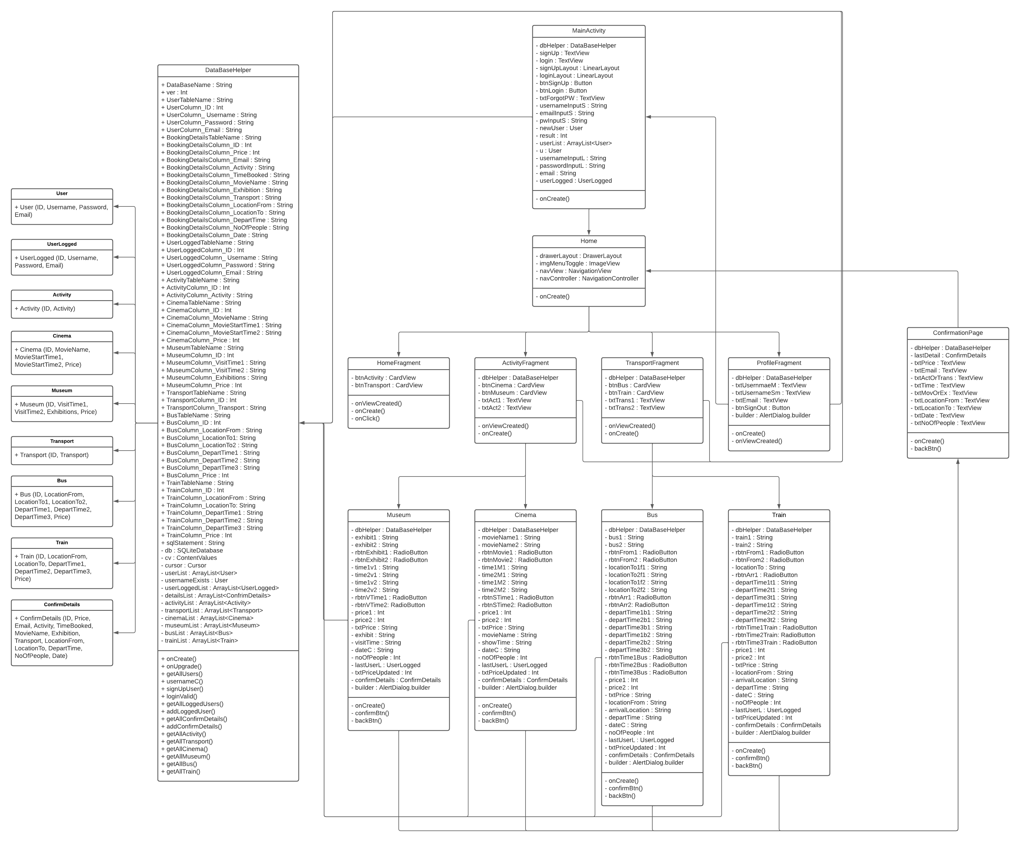While developing the Easy2Book application, the class diagram for the application had changed from the initial class diagram that was created for the first deliverable. Below is the updated version of the class diagram.

## Appendix 3 – ERD Diagram

Like with the class diagram, above, the ERD diagram has also changed while the application was being developed. Below, is the updated version of the ERD diagram.

